GINGER-LEMONGRASS SYRUP

__________________________________________________

A Feasibility Study Presented to the Faculty of the
Department of Financial Management
School of Accountancy and
Business Management
Saint Louis University
Baguio, City

_____________________________________________

In Partial Fulfillment of the Requirements
of the Course Feasibility Study
(Finman 9C)

_____________________________________________

By:
Rodrigo, Marla Gail A.
Sierra, Stephanie D.

December 2016
ACKNOWLEDGMENT

The proponents would like to express their sincere gratitude and appreciation to those who have extended their help, support and encouragement all throughout the completion of this feasibility study.
To the Heavenly Father who became the source of will, courage and wisdom, and who kept them safe from harm during the process of this undertaking, they dedicate this accomplishment to His greatness.
To their dearest adviser who gave them guidance, imparted constructive criticisms, and unbiased appreciation of their efforts and work, they will truly keep all the learning even after the years spent in the university.
To their families and friends who have also been very supportive in lending help in every possible way, the proponents whole-heartedly dedicate this work to them.
And to all the respondents who have answered kindly to our requests, this would not be effective without their actual participation in the study, thus, the proponents extend their utmost thanks to each and everyone who have contributed in this study.

-The Proponents

Table of Contents
Preliminary Pages Page No.
Title Page i
Indorsement Letter ii
Approval Sheet iii
Acknowledgment iv
Table of contents v
Appendices vi
List of Tables vii
List of Figures viii
List of Charts xi
CHAPTER I: PROJECT SUMMARY
Introduction 12
- Name of the Enterprise 12
- Location 13
- Vision-Mission Statement 13
- Logo of the Enterprise 14
- Descriptive Definition of the Project 14
- Related National Program 14
- Affinity to Regional Studies 16
- Project Potential and Proponents 17
- Project’s Long-Range Objectives 18
- Feasibility Criteria 19
- Highlights of the Projects 19
- History 19
- Project Timetable and Status 20
- Nature of the Industry 22
- Mode of Financing 22
- Investment Costs 22
- Major Assumptions and Summary of Findings and Conclusions 23
- Market Study 23
- Technical Study 23
- Financial Study 24
- Socio-Economic Study 24
- Organizational and Management Study 25
CHAPTER II: MARKET STUDY
Introduction 26
Product Description 26
- Name of Product 26
- Properties of Product 27
- Uses of Product 27
- Major Users of Product 27
- Geographical Area of Dispersion 27
Demand Analysis 28
Supply Analysis 39
Demand-Supply Analysis 43
Price Study 44
Factors Affecting the Market 45
1. Factors Affecting Demand 45
a. Consumer Taste and Preferences 45
b. Population Growth 45
c. Income Changes 46
d. Advertisements 46
2. Factors Affecting Supply 46
a. The Price of Commodity or input cost 46
b. Natural Conditions 47
c. Technology 47
G. Marketing Program 48
1. Product 48
2. Price 49
3. Place 50
4. Promotion 51
CHAPTER III: TECHINCAL STUDY
Introduction 53
- Production Description 53
- Manufacturing Process 54
- Production flowchart 56
- Plant Size and Production Schedule 56
- Machineries and Equipment 57
- Plant Location 58
- Vicinity Map 59
- Production Site 60
- Plant Layout 61
- Raw Materials and Supplies 62
- Utilities 64
- Waste Disposal 66
- Labor requirements 65
- Production Cost 66
- Project Cost 71

CHAPTER IV: FINANCIAL STUDY
Introduction 78
Major Assumptions 78
Income Statement 82
Projected Statement of Financial Position 95
Projected Statement of Cash Flow 103
Projected Statement of Partner’s Equity 104
Financial Ratio and Analysis 105
CHAPTER V: SOCIO-ECONOMIC STUDY
Introduction 110
- Employment Income 110
- Taxes 111
- Supply of Commodities 111
- Demand for Material 111
CHAPTER VI: ORGANIZATIONAL AND MANAGEMENT STUDY
Introduction 113
- Basic Consideration 113
- Form of Ownership 113
- Organizational Chart 114
- Officers and Key Personnel 114
- Guidelines and Policies 116

LIST OF TABLES
Table No. Page No.
- Historical Household Population 27
- Historical Demand 29
- Cross Tabulation 30
- Annualized Cross Tabulation 31
- Frequency Distribution on the Number of Respondents Who Uses Syrup 33
- Frequency Distribution on the Sizes and Quantity the Respondents Buy Syrup 33
- Frequency distribution on the Length of Time of Consumption of Syrup 34
- Frequency Distribution on the Willingness to Buy the GINGER-LEMONGRASS SYRUP 34
- Summary Table of Standard Deviation for Demand 35
- Standard Deviation of Statistical Parabolic Method 36
- Projected Demand Using Statistical Parabolic Method 37
- Actual Projected Demand Based on statistical Parabolic Method 37
- Distribution of Respondents Selling Syrup 38
- Annualized Supply 39
- Historical Supply 39
- Summary Table of Computed Standard Deviation 40
- Computation of Standard Deviation Using Statistical Parabolic Method 41
- Projected Supply 42
- Actual Projected Supply 42
- Unsatisfied Demand 43

List of Figures
No. Page
- Logo of the Enterprise 12
- The Product GINGER-LEMONGRASS FLAVORED SYRUP 48
- Sample Leaflet 50
- Official Facebook Page 51
- Image of the Production Area 59
- Floor Plan 60

List of Charts
No. Page
1 Gantt Chart 24
2 production flow chart 56
3 socio-economic chart 112
4 Organizational Chart 114

CHAPTER I
PROJECT SUMMARY
Introduction
Syrups are more than just any ordinary sweeteners, these are but infused syrups that are the ultimate flavor-booster for mixed drinks or cocktails, coffee, tea, juice, even cakes, ice cream sundaes, whipped creams, glaze to doughnuts and more. Health-wise, herbal and medicinal plants are one of the best options for most consumers, such as Ginger and Lemongrass. Thus, a feasibility study is conducted to determine the viability of Ginger-Lemongrass Syrup.
This chapter embodies the name of the enterprise, its logo, location, the project’s descriptive definition, long term objectives, feasibility criteria, highlight of the project, and the timetable. Moreover, integrating together with the national and local programs applicable and beneficial to the existence of the business, and the major assumptions, summary and conclusion in accordance to the market, technical, financial, socio-economic, and management of the project’s feasibility.
A. Name of the Enterprise
The name “Gingertwee Enterprise”, highlights the main ingredient of our product, Ginger – Lemongrass Syrup. The word “Twee” represents the child pronunciation of “sweet” which also means excessively or affectedly quaint, pretty, or sentimental, and sweet. The enterprise wanted to portray a natural and wholesome image along with a lighthearted new name that may be known and remembered by people, young and old.

B. Location of the Enterprise
The proponents have agreed upon establishing the enterprise, that the production and operation site will be at Unit A, located in No.17 Bonifacio Street, A. Bonifacio-Caguioa-Rimando, Baguio, Benguet. This location is a commercial property for rent that provides easy travel for restocking of raw materials and delivering of finished products to merchandising firms, retail stores and markets. A wide-range of customers will have the familiarity of the establishment, as schools, malls and other establishments are very near the location.
C. Vision-Mission Statement
VISION
Our vision is to become the pioneer producer of organic syrups in the whole City of Baguio and in the Philippines.
MISSION
Our mission is to provide quality and 100% natural syrups to public markets and independent grocers, and to support the consumption of healthy food and beverages throughout Baguio City and the Philippines.

D. Logo of the Enterprise
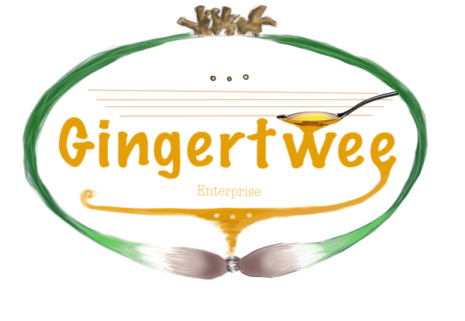
Figure 1. Logo of the Enterprise

The logo exemplifies all its organic and natural attributes, beginning with its color choice to every image it represents. The ginger aligned in the above center portrays a crown, which means that glory awaits in the future ahead. The lemongrass embracing the whole inner part of the image shows that everything else within are of importance. While the colors represent everything natural and organic, the dark-yellowish color represents the product of the company itself. And the product of our love and passion for work, the syrup, having poured out by a single spoon of which reflects the only provider of all great things, our Lord God.
E. Descriptive Definition of the Project
I. Related National Program
a. Go Negosyo (Philippine Center for Entrepreneurship)
This program is established by the Micro, Small, and Medium Enterprise Development (MSMED) Council who encourages public-private partnerships (PPPs) in the establishment and management of Negosyo Centers. While conducting expos such as Go Negosyo Mentor Me Program in key cities here in the Philippines, it also goes on with wider interaction through forums and mentoring sessions between participants and the entrepreneurs of Go Negosyo Program, focusing more on the development of entrepreneurship.
Small entrepreneurs are offered with free business registration assistance and product development, marketing, assistance to finance and business management, and business information and advocacy such as technology transfer and training/seminar assistance. On the basis of this program, Gingertwee enterprise may apply for the services offered and attend the seminars provided by Go Negosyo in DTI's Negosyo Center, Regional Office, and Baguio City.
b. Young Entrepreneurs Society (YES) Philippines – Membership
The Young Entrepreneurs Society is an organization established to educate, promote, encourage, network, and develop aspiring and successful entrepreneurs for excellence in business and professional growth. The organization provides a number of membership benefits through Monthly Networking and Executive forums through peer-to-peer learning and support, Quarterly learning events such as seminars on Business Planning, Marketing Strategy, Entrepreneurial Finance, and People Management. They also provide Online and personal training with free business pointers and tips from YES Philippines mentors and business coaches from different countries, business workshops, and Opportunities exchange.
Through adhering to the membership benefits of YES Philippines, the proponents are looking forward to attend the workshops, training programs and seminars provided by the organization, most especially, with its Opportunities exchange where the proponents may post business opportunities online for promotion of a wider network.

c. Work Attitude and Value Enhancement (WAVE) Program
The WAVE program by Business Coach, Inc. is based on the Corporation Code of the Philippines approved by the SEC. WAVE program allows the proponents to discover personal vision, mission and values that is aligned with the organization. The program reviews each of its participants from work values to corporate values and the components of ethical decision-making. Experiential learning experiences makes the participants discover their own work value system. Seminars on responsibility to others in the workplace, work productivity, decision making and even individual and corporate survival are offered by the Business Coach, Inc. as work organizations chart their course in the competitive global marketplace.
Through registering and joining Business Coach, Inc's programs, the proponents will learn more about how they can influence the strategic goals of their organization using the appropriate work attitude and values to achieve excellencefor Gingertwee's future application.
II. Affinity to Regional or Sectoral Studies
a. DOST - Academe Technology Based Enterprise Development (DATBED)
This program initiated by the Department of Science and Technology (DOST) develops entrepreneurial competencies among students in selected academic institutions. DATBED supports income generating projects with technological innovation that are yet tested in the market but with market potential and technically viable when commercialized. The program’s objective is to train students in enterprise development by providing them financial assistance for the establishment of technology-based enterprises.
This is an absolute help for the proponents being as young entrepreneurs, in lieu of learning from seminars, stages under DATBED are complied with accordingly. The first stage covers a period of three years for enterprise training and development, and the second stage are extensions of financial assistance, if there is a need for funding, to fully commercialize and promote the enterprise. Accordingly, the financial assistance should be paid back by the student through the Academic Institution which determines the terms of repayment.
b. Training Enhancement for Competitiveness in Harnessing Innovative Entrepreneurs (TECHIE)
The project TECHIE by the Department of Trade and Industry is a project under Region I that is to enhance competitiveness of SMEs thru technology trainings, to enhance global presence thru website promotion of products and services, to provide skills in electronic promotion of collaterals / materials, and facilitate E-Commerce transactions. The project also aims to strengthen market promotion, research through the use of websites and other applications.
The proponents adhere to the program with its IT-enabling trainings, allowing us to learn more of the modern advertising and promotion of our products through web development for Electronic Brochures / Bulletins, and to improve with our operations, and lessen operational cost through the use of available technology and application.
II. Project Potential and Proponents
In the creation of the Gingertwee Enterprise, since there is an increasing demand for organic, safe, and natural products, the partners came up with making what most consumers need and want, all the more in terms of food and beverages. The Ginger-Lemongrass Syrup by Gingertwee is rich in anti-oxidants, and lemonal or citral, which contains anti-fungal and anti-microbial qualities, also having the ability to support healthy cholesterol levels, cleanse and detoxify. According to a study in Georgia State University, ginger extracts having anti-inflammatory and anti-oxidants, are proven to have anti-cancer agents and was revealed to shrink prostate tumor size by 56%. And since Gingertwee’s syrup is a fusion of Ginger and lemongrass natural extracts, this product is very versatile since it has several household uses, as such are for food and beverage sweeteners, for teas, cocktails, pancakes, doughnuts, and more.
F. Project Long Range Objectives
In a period of ten (10) years, the Gingertwee Enterprise aspires to achieve the following objectives:
- Purchase additional machine and equipment such as a “Helicoidal Juice Extractor” which has a unique spiral design ensuring a high yield juice recovery without making it bitter, a Syrup Making Machine and Labeling Machines for Syrup bottles.
- Innovate through improved research and development studies such as introducing a variety of simple syrups that are unique and creative. Providing of which are ideas such as making floral syrups, and products possible aside from syrups (i.e., candies, powdered sweeteners, etc.)
- Form more and new contracts to established supermarkets, and also cater cake and bake shops in Baguio City.

G. Feasibility Criteria
One of the Gingertwee Enterprise’s core reasons of existence is to obtain and benefit from the profits gained from its operation. Upon the benefit of which, the proponents of the enterprise concluded to allocate its reserves for further innovation of quality performance in producing quality products, and compete therewith to other similar entities. Being able to compete and survive among the many errands of all enterprises succeeds in gaining advantage in comparison to others. The proponents of the enterprise aims for success with its product, Ginger – Lemongrass Syrup as it creates a new image and taste for any ordinary syrup found in the market. Being made of natural raw materials containing no harmful chemicals, the project aims to interest new customers for its uniqueness, number of benefits, and uses. With the survey provided, most respondents (residents of Baguio City) are willing to buy and try the product. Thereby, having an immense probability of increasing the product’s familiarity to a wide range of customers, and be known as the pioneer of herbal and medicinal syrups.
H. Highlights of the Project
1. History of the Project
Choosing the right product is really difficult. Unaware that the conversation went to some other topics, one of it is about a rhizome plant, ginger root or simply ginger. Since the researchers wanted to add a little twist to a syrup, the researchers decided to add something that the people would want to try or had to come up with something new and unique. The researchers figured out that if syrup would be more than just a sweet flavoring, it would attract the attention of buyers. So, the group thought of how it can be consumed by people easily with its nutrient still intact while having a low price. Thus, the researchers came up with a health-benefit syrup.
2. Project Timetable and Status
a. Project Proposal and Feasibility Study (August 2016 – December 2016)
Before starting the business, conducting a research is essential to be able to produce a product that will easily be marketable and profitable as well. The proponents will try to make the product just right as possible during this time for the preparation of starting the business. Through research is needed to be able to produce a product that has the potential to be the best selling product. The proponents gathered necessary data needed for the study such as the floating of questionnaires answered by the respondents. This study also helps the proponents to know whether the project is feasible or not.
b. Procurement of Funds (October 2016)
The funds that will use to start the business will be used to generate to begin the enterprise. The proponents will each contribute money from their personal funds with the help of their family, relatives and friends.
c. Business Registration and Licenses (1st and 2nd week November 2016)
Before starting the operations of the business, the enterprise should complete several requirements and go through legal processes. In order for our business to operate legally, the proponents will register the business in Securities and Exchange Commission for the business name, other permits includes the Application for Partnership, Business Permit, BIR, Working Permit, Fire Inspection Certificate and Sanitary Permit. These documents will be secured from different government agencies in the city.
d. Selection and Hiring of Employees (3rd week and 4th week of November 2016)
The enterprise will hire employees who possess the required qualifications set by them. The employees will also be oriented with the work they are engaged in like familiarizing them with the equipment in the working area. It will take three weeks to select and hire employees to ensure the production is efficient and effective.
e. Purchasing of Equipment, Furniture, and Raw Materials (1st and 2nd week of December 2016)
The allotted time to improve the working area and to acquire equipment, furniture, and raw materials. It will take us one week in total.
f. Advertising and Promotional Activities (3rd and 4th week of December 2016)
This period will be used to promote the enterprise and the product to be offered. One month is allotted for advertising and promotional activities before the start of operation to let people know about the enterprise. Advertising will be through distributing of flyers on different establishments, and posting advertisements through social media websites that will help promote the enterprise and the product as well.
g. Start of Business Operation (January 2017)
The enterprise will start its operations and is ready to serve the target market. An opening event will be held on this day, providing free tastes of the product and discounts.
3. Nature of the Industry
The Gingertwee Enterprise belongs to the condiments industry in which it produces Syrup with ginger and lemongrass extract. Since the business is involved in making syrup products to be delivered and distributing the products into different stores, supermarkets and in the public market within Baguio City. The enterprise will be under the small-medium enterprise that desires to delight customers and to offer them product that is delicious, affordable, and at the same time full of health benefits needed by every individual.
4. Mode of Financing
The funds for the project will be coming from each of the member’s capital contribution. They will equally contribute an amount of Php105,000.00 which would be in the form of cash. It will come from the proponents’ personal savings and borrowed from the family.
5. Investment Cost
The partners will contribute equally for initial capital investment which will amount to a total of Php210,000.00. The cash contributions will be used for the purchasing of the raw materials, machineries and equipment, tools, furniture and fixtures and supplies, and others which is necessary for the start of operation of the business. The procurement of fund will start immediately after the end of first semester. Any excess in the fund will be used for precautionary motives.

Major Assumptions and Summary of Findings and Conclusion
1. Market Study
Market study analyzes market demand for a particular product. Its demand and supply status must be considered to constitute such structure. In entering the market, the enterprise must have strategies on how to introduce the product to the public by making promotions such as advertisements in social media, posters and banners in different supermarket and grocery stores within Baguio City. The name of the product must be considered in a way that it is easy to catch the attention of customers. The price must be affordable and fit to the quality of product. The enterprise must also consider the factors affecting the market like the taste and preference, consumer, price, cost, machinery malfunction and the marketing program are not neglected for it will cause delay in delivering the product and it will lead to loss of customers.
2. Technical Study
The Gingertwee Enterprise is involved in making syrup particularly the ginger- lemongrass syrup in which the main ingredients used by the enterprise are ginger and lemongrass which are most available in the market. The plant location and plant layout, the structure's specification, the raw materials to be used by the proponents to start the enterprise is also defined in the next chapter.
The enterprise will operate eight (8) hours a day from 8:00 am until 5:00 pm, Mondays to Fridays. The price of the product is Php60.00 per bottle. The total project cost will be Php 210,000. This includes all current and non-current assets, expenses of supplies and raw materials needed for one month operation. The cost may vary from time to time because of ever changing market but the proponents are willing to stabilize its production and price by looking for ways to lower the cost and not affecting the quality of the product. All the tools, utensil, machineries and equipment needed would be bought so that the production will be faster.
3. Financial Study
The preparation of financial statements and schedule which serves as proof of profitability of the business is found in this section. This presents the very details of the accounts and transactions that concern the business.
The financial study determines the profitability of the project. It will show the information on the total project cost, initial capital and financial analysis of the project. It illustrates how the business will be financed so that it will be managed and will earn through the years of its operation from its opening. The proponents are finding ways on how to have the least cost possible but will be able to maximize profit. The study of the finances shall make sure that the proposed business will be feasible and can be launched in the market.
4. Socio-economic Study
In putting up a business, it is not always gaining income but is also about contributing to the economy of the country. It will have to consider if the community have something to gain so as the enterprise.
The Gingertwee Enterprise sees to it that it contributes to the general welfare of the society by opening job opportunities in the community, paying taxes to the government, introducing a product to the public that can help improve their health in the form of a syrup and by following proper waste disposal in a way that it will not cause harm to the health of the people in the community and as well as with mother nature.
5. Organizational and Management Study
The Gingertwee Enterprise is comprised of 2 proponents who shall divide the profit and loss equally. Partners are also part of the employees of the business. Each of them has their own parts which will be in the financing for the management and for the sales and operations. They have their own share of work until the business will grow. There will also be two (2) helpers that are to be employed and chosen according to their job qualification to run the operations of the business. They must work at 8:00am to 5:00pm with one hour lunch break from 12:00noon to 1:00pm and two 15- minutes break in the morning and in the afternoon. Employees must observe punctuality at the official time set. Non - attendance of a working day by any reason shall be considered as absence unless there is a written application for leave and if circumstance is under forced leave or by reason of emergency, ailment or fortuitous event. All employees are open to a 15-day leave without pay in a year. For sick leave, 3 days will require a medical certificate from an attending physician. In case of accidents within the premises of the business establishment, the company shall assume liability. There will also be sanctions for violations of unauthorized absences and misconduct in the enterprise.

Activities | August | September | October | November |  |  |  |  | December |  |  |  |  |  |  | January
a. Project Proposal and Feasibility Study
b. Procurement of Funds
c. Business Registration and Licenses
d.. Selection and Hiring of Employees
e. Improvement of working Area and purchasing of Equipment, Furniture, and Raw Materials
f. Advertising and Promotional Activities
g. Start of Business Operation

CHAPTER II
MARKET STUDY
Introduction
Market study determines the marketability of the project and it is considered to be the overall result of the enterprise. It provides information to identify the price of the product and how the demand and supply will respond to the price changes. This chapter presents the product’s name, properties, uses, geographical dispersion and the computation of demand and supply analysis. With this information it will determine the marketing programs and different factors affecting the market of the product.
- Product description
- Name of the product
The name of the product is “Ginger-lemongrass Syrup”, the proponents have chosen this name because of the main ingredients of the product which are ginger and lemongrass. The proponents combined the word ginger and lemongrass to let potential customers to discern immediately what the product is, in which it will encourage them to avail the product.
- Properties of the product
The Ginger Lemongrass Syrup is composed of ginger and lemongrass which are beneficial to our body. Ginger is called ginger root or simply ginger and it is commonly used as spice. One important contents of ginger is the “gingerol” which is a bioactive compound that it has powerful anti-inflammatory and antioxidant effects to our body. The following are common benefits of ginger: it lower blood sugar and improve heart disease risk, it also reduces muscle pain and soreness, it can also help treat Chronic indigestion, and etc. another component of the product is the lemongrass, which is also beneficial to our body because of its medicinal properties including analgesic, anti-inflammatory, antidepressant, antipyretic, antiseptic, antibacterial, antifungal, astringent, carminative, diuretic, febrifuge, galactogogue, insecticidal, sedative, and anti-cancer properties. The following common benefits of lemongrass are: it helps digestion, control cholesterol levels, cleanses and detoxifies, heals colds and flu, fights cancer, and reduces arthritis pain.
The packaging material of the product is a plastic bottle with a plastic cover in which it can be recycled and it is 375ml.
- Uses of the product
Ginger Lemongrass Syrup is an ultimate flavor-booster for mixed drinks or cocktails, coffee, tea, juice, even cakes, ice cream sundaes, whipped creams, glaze to doughnuts and more. All the health benefits of ginger and lemongrass are present in every serving of the product. The product can be consumed any time of the day either breakfast, lunch or dinner.
- Users of the product
The primary users of the product will be the household population because the product could be usually used inside the house and share by the family. The enterprise will be catering any age group who wishes to avail the product and it has no specific gender consumer. The product caters to all people who reside in Baguio City and those who come and visit the place.

- Geographical areas of dispersion
The Ginger Lemongrass Syrup will be found at selected supermarkets and different stores in Baguio City that sell organic products. The place of production will be at Unit A, located in No.17 Bonifacio Street, A. Bonifacio-Caguioa-Rimando, Baguio, Benguet.
B. Demand analysis
In the analysis of the demand for the product, GINGER-LEMONGRASS flavored syrup, the proponents held a floating of questionnaires in the different households of Baguio City. The proponents have conducted an analysis on demand to determine the familiarity of the target market to the product, and the units they are likely to purchase. This also led the proponents to obtain the current total number of household population of Baguio City regardless of age or gender brackets. The result from the Historical Demand and Projected Demand illustrates that there is a direct relationship between population and demand, thus having an increase in population means an increase in demand. And with this analysis, the Gingertwee Enterprise shall take the opportunity to commence its operation in Baguio City.
Table 1
Historical Household Population
YEAR | Historical Household Population
2011 | 79,906
2012 | 81,848
2013 | 83,837
2014 | 85,874
2015 | 87,961

Table 1 shows the Historical Household Population of Baguio City from the years 2011 to 2015. The information on the five-year projected population was taken from the office of the Philippine Statistics Authority in Baguio City. The Household, as the chosen target market, is mostly known to consume products in lined with condiments used in preparing food and beverages, and one of such is syrup.
With the basis of statistics, the Slovin’s Formula was used to arrive with the sample size of the study as shown below, and the margin of error having a 5% rate.
Slovin’s formula
$$n=\frac{N}{1+Ne^{2}}$$
$$n=\frac{87,961}{1+{87,961(0.05)}^{2}}$$
$$n=398.1892 \sim 399$$
Where: N = the total household population of Baguio City
e = the degree error
n = the sample size
In the computation above, the computed sample size is 399 from the total population of Baguio City on 2015, which will be the basis of the total number of questionnaires to be distributed.

Table 2
Historical Demand
Year | Population | Percentage of Consumption | Consumption Rate | Historical Demand
2011 | 79,906 | 72.50% | 23 | 1,332,432.55
2012 | 81,848 | 72.50% | 23 | 1,364,815.40
2013 | 83,837 | 72.50% | 23 | 1,397,981.98
2014 | 85,874 | 72.50% | 23 | 1,431,948.95
2015 | 87,961 | 72.50% | 23 | 1,466,749.68

The table shows the Historical Demand in 5 years. The values shown for Historical Demand are computed by multiplying the Historical Household Population, Percentage of Consumption, and the Consumption Rate. The table also shows that as the Population of Household increases, the Demand for Ginger-Lemongrass Syrup increases. With a total of 400 respondents, 72.50% claimed that they use Syrups in their household.

Table 3
Cross Tabulation
Frequency | Quantity
 | 250 mL |  |  |  | 375mL |  |  |  | 500mL |  |  |  | 540mL |  |  |  | 750mL
 | 1 | 2 | 3 | 4 | 1 | 2 | 3 | 4 | 1 | 2 | 3 | 4 | 1 | 2 | 3 | 4 | 1 | 2 | 3 | 4
One Week | 0 | 3 | - | - | 43 | 2 | - | - | 2 | 1 | - | - | - | - | - | - | 1 | - | - | -
Two Weeks | 12 | 4 | 1 | - | 1 | - | - | - | 6 | - | - | - | - | - | - | - | - | - | - | -
Three Weeks | 14 | 1 | - | - | 7 | 4 | - | - | 18 | 7 | - | - | - | - | - | - | - | - | - | -
One Month | 20 | - | 1 | - | 70 | 2 | - | - | 23 | - | - | - | 4 | 1 | - | - | 5 | 1 | - | -
others:
Two Months | 4 | - | - | - | 3 | 1 | - | - | 3 | - | - | - | - | - | - | - | 1 | - | - | -
Three Months | - | - | - | - | - | 1 | - | - | 1 | - | - | - | - | - | - | - | - | - | - | -
Four Months | - | - | - | - | - | - | - | - | 1 | - | - | - | - | - | - | - | - | - | - | -
Five Months | - | - | - | - | - | 1 | - | - | 1 | - | - | - | 1 | - | - | - | - | - | - | -
Six Months | 1 | - | - | - | - | - | - | - | 1 | 1 | - | - | - | 2 | - | - | 1 | - | - | -
Seven Months | - | - | - | - | - | - | - | - | - | - | - | - | - | 1 | - | - | 2 | - | - | -
One Year | - | - | - | - | - | - | - | - | - | 2 | - | - | - | 2 | - | - | 4 | - | 1 | -
Total | 51 | 8 | 2 | 0 | 124 | 11 | 0 | 0 | 56 | 11 | 0 | 0 | 5 | 6 | 0 | 0 | 14 | 1 | 1 | 0
Total | 61 |  |  |  | 135 |  |  |  | 67 |  |  |  | 11 |  |  |  | 16

Table 3 shows the Cross Tabulation on how often the household of Baguio City consume Syrup based on the period in weeks and months in the table, and the quantity consumed in milliliters (mL). Based on the Survey conducted, the findings show that most of the respondents often buy 1 bottle of 375mL syrup every month.

Table 4

Annualized Cross Tabulation

 | 250 mL |  |  |  | 375mL
 | 1 | 2 | 3 | 4 | 1 | 2 | 3 | 4
One Week | - | 78,000 | - | - | 838,500 | 78,000 | - | -
Two Weeks | 78,000 | 52,000 | 19,500 | - | 9,750 | - | - | -
Three Weeks | 59,500 | 8,500 | - | - | 44,625 | 51,000 | - | -
One Month | 60,000 | - | 9,000 | - | 315,000 | 18,000 | - | -
others: |  |  |  |  |  |  | - | -
Two Months | 6,000 | - | - | - | 6,750 | 4,500 | - | -
Three Months | - | - | - | - | - | 3,000 | - | -
Four Months | - | - | - | - | - | - | - | --
Five Months | - | - | - | - | - | 1,800 | - | -
Six Months | 500 | - | - | - | - | - | - | -
Seven Months | - | - | - | - | - | - | - | -
One Year | - | - | - | - | - | - | - | -
Total | 204,000 | 138,500 | 28,500 | - | 1,214,625 | 156,300 | - | -
Total | 371,000 |  |  |  | 1,370,925

 | 500mL |  |  |  | 540mL |  |  |  | 750mL
 | 1 | 2 | 3 | 4 | 1 | 2 | 3 | 4 | 1 | 2 | 3 | 4
One Week | 52,000 | 52,000 | - | - | - | - | - | - | 39,000 | - | - | -
Two Weeks | 78,000 | - | - | - | - | - | - | - | - | - | - | -
Three Weeks | 153,000 | 119,000 | - | - | - | - | - | - | - | - | - | -
One Month | 138,000 | - | - | - | 25,920 | 12960 | - | - | 45,000 | 18,000 | - | -
others:
Two Months | 9,000 | - | - | - | - | - | - | - | 4,500 | - | - | -
Three Months | 2,000 | - | - | - | - | - | - | - | - | - | - | -
Four Months | 1,500 | - | - | - | - | - | - | - | - | - | - | -
Five Months | 1,200 | - | - | - | 1,296 | - | - | - | - | - | - | -
Six Months | 1,000 | 2,000 | - | - | - | 4,320 | - | - | 1,500 | - | - | -
Seven Months | - | - | - | - | - | 1,836 | - | - | 2,550 | - | - | -
One Year | - | 2,000 | - | - | - | 2.160 | - | - | 6,000 | - | 2,250 | -
Total | 435,700 | 175,000 | - | - | 27,216 | 21,276 | - | - | 98,550 | 18,000 | 2,250 | -
Total | 610700 |  |  |  | 48,492 |  |  |  | 118,800

The Annual Consumption Rate is computed below:
Computation of Usage Rate | Totals
Total Annual Consumption (in mL)
250mL | 371,000
375mL | 1,370,925
500mL | 610,700
540mL | 48,492
750mL | 118,800
Total Annual Consumption: | 2,519,917
Divide by mL of proposed packaging | 375
Annual Consumption of Respondents (in mL) | 8,689
Divided by: No. of Respondents Consuming Syrup | 290
Annual Consumption Rate (in mL): | 23

The tables show the consumption of syrup every year which is computed by adding the totals of the multiplied bottle size (in mL), the quantity or number of bottles consumed, the period of consumption, and the number of consumers referred in the cross tabulation. Table 4 shows the Total Annual Consumption or usage of syrup is 2,519,917 in mL and the Annual Consumption rate is 23, the computation is shown above, this means that on the average, a person consumes 23 bottles of syrup every year.
This is a relatively positive result since one (1) person consumes almost three (3) bottles a month or one (1) bottle of syrup a week.

Table 5
Frequency Distribution on the Number of Respondents Who Uses Syrup
Response | Number of Respondents | Percentage
Yes | 290 | 72.50%
No | 110 | 27.50%
Total | 400 | 100.00%

Table 5 illustrates that there are 290 out of 400 respondents who consume syrup with an equivalent rate of 72.50%, this implicates that majority of the respondents from the survey are potential buyers.
Table 6
Frequency Distribution on the Sizes and Quantity the Respondents Buy Syrup
Responses | No. of Respondents | Percentage
250mL | 61 | 21.03%
375mL | 135 | 46.55%
500mL | 67 | 23.10%
540mL | 11 | 3.79%
750mL | 16 | 5.52%
TOTAL | 290 | 100.00%

Table 6 shows the size and the quantity of syrup bottles that the respondents usually buy. Based from the data above, the size of syrup bottle purchased most by the respondents is the 375mL bottle. For the quantity, most respondents usually buy one (1) bottle of syrup a month. Thus, the proponents decided to produce the 375mL bottles of syrup.
Table 7
Frequency distribution on the Length of Time of Consumption of Syrup
Response | Number of Respondents | Percentage
One Week | 52 | 17.93%
Two Weeks | 24 | 8.28%
Three Weeks | 51 | 17.59%
One Month | 127 | 43.79%
Others: Two Months | 12 | 4.14%
Three Months | 2 | 0.69%
Four Months | 1 | 0.34%
Five Months | 3 | 1.03%
Six Months | 6 | 2.07%
Seven Months | 3 | 1.03%
One year | 9 | 3.10%
Total | 290 | 100.00%

In Table 7, the data on the length of time of consumption shows the result of most respondents consuming the product for one month. This is a positive result since most potential buyers consume this fast, and purchase more of the product in a short period which is less than a year. The proponents have also found that the product will last up to four (4) months at most.
Table 8
Frequency Distribution on the Willingness to Buy the GINGER-LEMONGRASS SYRUP
Response | Number of Respondents | Percentage
Yes | 321 | 80.25%
No | 79 | 19.75%
Total | 400 | 100.00%

Table 9 shows the willingness of the respondents to avail the product. The result provides that 321 out of 400, that is 80.25% of the respondents are willing to purchase the product. This makes the product marketable to the household of Baguio.
Table 9
Summary Table of Standard Deviation for Demand
Method | Standard Deviation
Arithmetic Straight Line | 1,050.02
Arithmetic Geometric Curve | 32,699.68
Statistical Straight Line | 673.69
Statistical Parabolic Curve | 7.13

Table 9 shows the summary of standard deviation based on the different statistical methods used. These methods were namely, Arithmetic Straight Line, Arithmetic Geometric Curve, Statistical Straight Line, and Statistical Parabolic Curve. Given the Standard Deviations from these methods, the Statistical Parabolic will be used by the enterprise since it has the lowest risk of getting errors and can provide a more accurate and realistic demand for the product.

Table 10
Standard Deviation of Statistical Parabolic Method
Year | Y | X | X² | X⁴ | XY | X²Y
2011 | 1,332,432.55 | -2 | 4 | 16 | -2,664,865.10 | 5,329,730.20
2012 | 1,364,815.40 | -1 | 1 | 1 | -1,364,815.40 | 1,364,815.40
2013 | 1,397,981.98 | 0 | 0 | 0 | 0.00 | 0.00
2014 | 1,431,948.95 | 1 | 1 | 1 | 1,431,948.95 | 1,431,948.95
2015 | 1,466,749.68 | 2 | 4 | 16 | 2,933,499.35 | 5,866,998.70
TOTAL | 6,993,928.55 | 0 | 10 | 34 | 335,767.80 | 13,993,493.25

a | + | b | (x) | + | c | X² | = | Yc | Y - Yc | (Y - Yc)²
1,397,981 | + | 33,577 | (2) | + | 403 | 4 | = | 1,332,437 | -5 | 23
1,397,981 | + | 33,577 | (1) | + | 403 | 1 | = | 1,364,806 | 9 | 82
1,397,981 | + | 33,577 | 0 | + | 403 | 0 | = | 1,397,981 | 1 | 2
1,397,981 | + | 33,577 | 1 | + | 403 | 1 | = | 1,431,960 | -11 | 120
1,397,981 | + | 33,577 | 2 | + | 403 | 4 | = | 1,466,744 | 5 | 27
TOTAL |  |  |  |  |  |  |  |  |  | 254

Where:
a = $\frac{(ΣX⁴) (ΣY) – (ΣX²) (Σ X²Y)}{n\left(ΣX^{4}\right)- {(ΣX²)}^{2}}$ b = $\frac{ΣXY}{ΣX²}$
c = $\frac{n \left(Σ X^{2}Y\right)-(ΣX²) (ΣY)}{n\left(ΣX^{4}\right)- {(ΣX²)}^{2}}$ Yc = a+bx+cx²
Standard Deviation = $\sqrt{\frac{Σ(Y - Yc)²}{Total no.of years}}$ = $\sqrt{\frac{254}{5}}$ = 7.13

Table 10 shows the computation of standard deviation using the Statistical Parabolic Method. This method resulted the lowest standard deviation which implies to have the least degree of error, this is also the most favorable method to use in projecting the demand for the next years of operation.
Table 11
Projected Demand Using Statistical Parabolic Method
Year | A | b | X | C | X² | Yc
2016 | 2,085,653 | 50,093 | 3 | 601 | 9 | 2,241,338
2017 | 2,085,653 | 50,093 | 4 | 601 | 16 | 2,295,636
2018 | 2,085,653 | 50,093 | 5 | 601 | 25 | 2,351,135
2019 | 2,085,653 | 50,093 | 6 | 601 | 36 | 2,407,835
2020 | 2,085,653 | 50,093 | 7 | 601 | 49 | 2,465,736

Table 12 shows the computation of the projected values for getting the actual projected demand. Where Projected demand is computed by adding the value of a, bx, c and X².
Table 12
Actual Projected Demand Based on statistical Parabolic Method
Year | Projected Demand | Percentage of Willingness | Actual Projected Demand
2016 | 2,241,338 | 80.25% | 1,798,674
2017 | 2,295,636 | 80.25% | 1,842,248
2018 | 2,351,135 | 80.25% | 1,886,786
2019 | 2,407,835 | 80.25% | 1,932,288
2020 | 2,465,736 | 80.25% | 1,978,753

Table 12 shows the actual projected demand for the succeeding five years (2016-2020). The computation for the actual projected demand is made by multiplying the projected demand from the Statistical Parabolic Method and the percentage of the household who are willing to avail the Ginger-Lemongrass Syrup. Based on the above data, the highest demand for the syrup is in the year 2020 and the lowest demand is in the year 2016. This means that the increase in the actual projected demand every year results from the percentage of the consumer’s willingness to purchase the product.
- Supply Analysis
Supply is defined as the schedule of how much producers are willing and able to sell at the amount available at a specific price or the amount available across the range of prices. Supply analysis is a marketing study in which it identifies its direct and indirect competitors selling the same product in the market. The existence of the competitors proves the marketability of the proposed product.
Table 13
Distribution of Respondents Selling Syrup
Establishment | Size (mL) | quantity | Monthly sales | Percentage of increase or decrease (%)
A | 375 | 4 | 1,500 | 3
 |  |  | 1,500
B | 375 | 15 | 5,625 | 3
 |  |  | 5,625
C | 375 | 20 | 7,500 | 8
 | 500 | 20 | 10,000
 |  |  | 17,500
D | 500 | 5 | 2,500 | 3
 | 750 | 5 | 3,750
 |  |  | 6,250
E | 375 | 2 | 750 | 3
 | 750 | 10 | 7,500
 |  |  | 8,250
F | 375 | 5 | 1,875 | 5
 | 500 | 5 | 2,500
 | 750 | 5 | 3,750
 |  |  | 8,125
Total |  |  | 47,250 | 25

Table 14
Annualized Supply
Establishment | Annual Sales (in mL) |  |  | Total
 | 375mL | 500mL | 750mL
A | 18,000 | - | - | 18,000
B | 67,500 | - | - | 67,500
C | 90,000 | 120,000 | - | 210,000
D | - | 30,000 | 45,000 | 75,000
E | 9,000 | - | 90,000 | 99,000
F | 22,500 | 30,000 | 45,000 | 97,500
TOTAL | 207,000 | 180,000 | 180,000 | 567,000

This table summarizes the annual sales of syrup.
Table 15
Historical Supply
Year | Historical Supply
2011 | 2,338.08
2012 | 2,439.74
2013 | 2,545.81
2014 | 2,656.50
2015 | 2,772.00

Computation for historical supply for 2015:
= (total annual sale/total number of respondents) * total number of competitors
= (567,000 / 6 / 375mL) * 11
= 2,772
Historical Supply for 2014:
= Historical supply of 2015 * (1-0.04167)
= 2,772* 0.9583
= 2,656.50
Total percentage change 25%
Divide by: number of respondents 6___
Average change in sales 4.17%

The above table shows the historical supply of syrup from 2011 to 2015. In computing the historical supply, the total annual sales in year 2016 serves as the base year to be divided by the total number of respondents and the answer will be multiplied by the total number of competitors.
Table 16
Summary Table of Computed Standard Deviation
Methods of Projection | Computed Standard Deviation
Arithmetic Straight Line | 6.02
Arithmetic Geometric Curve | 44.29
Statistical Straight Line | 3.86
Statistical Parabolic Curves | 0.056

Table 16 shows the computed standard deviation for each of the four methods needed in choosing the right method of projection. Since the statistical Parabolic method has the least standard deviation, and then it will be the method to be used to get the projection of demand to lessen the risk. It will also be used because it is most likely to come up with the most realistic projection of supply.

Table 17
Computation of Standard Deviation Using Statistical Parabolic Method
Year | Y | X | X² | X⁴ | XY | X²Y
2011 | 2,338.08 | -2 | 4 | 16 | -4,676.16 | 9,352.33
2012 | 2,439.74 | -1 | 1 | 1 | -2,439.74 | 2,439.74
2013 | 2,545.81 | 0 | 0 | 0 | 0.00 | 0.00
2014 | 2,656.50 | 1 | 1 | 1 | 2,656.50 | 2,656.50
2015 | 2,772.00 | 2 | 4 | 16 | 5,544.00 | 11,088.00
TOTAL | 12,752.13 | 0 | 10 | 34 | 1,084.60 | 25,536.56

A | b | (x) | C | X² | Yc | Y-Yc | (Y-Yc)
2,546 | 108 | (2) | 2 | 4 | 2,338 | -0.039149 | 0.001533
2,546 | 108 | (1) | 2 | 1 | 2,440 | 0.078060 | 0.006093
2,546 | 108 | 0 | 2 | 0 | 2,546 | 0.000716 | 0.000001
2,546 | 108 | 1 | 2 | 1 | 2,657 | -0.079015 | 0.006243
2,546 | 108 | 2 | 2 | 4 | 2,772 | 0.039388 | 0.001551
 |  |  |  |  |  |  | 0.015421
Where:
a = $\frac{(ΣX⁴) (ΣY) – (ΣX²) (Σ X²Y)}{n\left(ΣX^{4}\right)- {(ΣX²)}^{2}}$ c = $\frac{n \left(Σ X^{2}Y\right)-(ΣX²) (ΣY)}{n\left(ΣX^{4}\right)- {(ΣX²)}^{2}}$
=$\frac{\left(34\right)\left(12,752.13\right)-(10)(25,536.56)}{5\left(34\right)-{10}^{2}}$ =$\frac{5\left(25,536.56\right)-(10)(12,752.13)}{5\left(34\right)-{10}^{2}}$
= 2,546 = 2
b = $\frac{ΣXY}{ΣX²}$ Yc = a+bx+cx²
= $\frac{1,084.60}{10}$ = 108
Standard Deviation =$\sqrt{\frac{Σ(Y - Yc)²}{Total no.of years}}$ = $\sqrt{\frac{0.015421}{5}}$ = 0.056
Table 18
Projected Supply
Year | A | b | X | C | X² | Yc
2016 | 954,679 | 40,673 | 3 | 865 | 9 | 1,084,484
2017 | 954,679 | 40,673 | 4 | 865 | 16 | 1,131,213
2018 | 954,679 | 40,673 | 5 | 865 | 25 | 1,179,672
2019 | 954,679 | 40,673 | 6 | 865 | 36 | 1,229,861
2020 | 954,679 | 40,673 | 7 | 865 | 49 | 1,281,782

Table 19
Actual Projected Supply
Year | Actual Projected Supply
2016 | 1,084,484
2017 | 1,131,213
2018 | 1,179,672
2019 | 1,229,861
2020 | 1,281,782

- Demand-Supply Analysis
After determining the demand and supply in the market, there is a need to compare the result and get the summations of the projected demand and supply for the years 2016 to 2020.

Table 20
Unsatisfied Demand
Year | Projected Demand | Projected Supply | Unsatisfied Demand
2016 | 1,205,623 | 1,084,484 | 121,139
2017 | 1,234,830 | 1,131,213 | 103,617
2018 | 1,264,683 | 1,179,672 | 85,011
2019 | 1,295,182 | 1,229,861 | 65,321
2020 | 1,326,327 | 1,281,782 | 44,546

Table 20 shows the unsatisfied demand for the next five years of the enterprise. It also shows that the projected supply is lower than the actual demand in which the market cannot supply the demand for the product. Thus, it means that our product has a potential to be marketable. It also indicates that as the actual projected demand and actual projected supply increases, the number of unsatisfied demand decreases.
- Price Study
Price is one of the primary considerations of consumers in their decision on whether to buy the product or not. It is important to determine the price to be able to meet consumers need as well as to gain competitive advantage in the market.
The proponents will introduce the product at an affordable price. This may attract customers to try and buy Ginger Lemongrass Syrup when weighing their choices. The Ginger Lemongrass Syrup will be sold at Php 60.00 at the size of 375ml. the price covers all the cost and also a 30% mark-up.
F. Factors Affecting the Market
There are different factors that the proponents have considered known to affect the business and the changes it may contribute to the market.
1. Factors Affecting Demand
a. Consumer Taste and Preferences
Health and wellness products in the Philippines maintained its positive development in 2015 based on a market research provided by Euromonitor International. This development continued as manufacturers sustained to develop new products that were not only healthy but also offered greater convenience to consumers, and also helped to maintain robust growth in current value sales. Consumers are influenced in purchasing more healthy and natural products through the campaigns and regulations on health and wellness by the government, and also through the promotions of most companies in compliance to such regulations.
With GINGER-LEMONGRASS SYRUP, the product offers natural and organic quality that is beneficial to consumers in health and convenience for its versatility in various uses.
b. Population Growth
The growing population of Baguio City brings an advantage to the study since the demand is growing as well. With the percentage of demand growing, there is a greater opportunity for the Gingertwee Enterprise to commence on its operation.
c. Income Changes
The change of income share in Baguio City’s population is a factor for demand. If there is an increase in income, the household’s purchasing power increases as well. Once the ability to purchase rises, the demand for the product increases which can lead to an increase in the market price since raw materials and other supplies have also increased its value.
d. Advertisements
Through effective advertisements, the proponents decided to float flyers, and create a web page in social media. With the distribution of flyers in different public places in Baguio City and with the familiarity of a wider population in social media, there will be a more scope of interested customers for the product.
2. Factors affecting supply
The supply may be influenced by different factors which are the price of commodity or input cost, natural conditions, and technology.
- The Price of Commodity or input cost
The cost of raw material, utilities, labor, licensing fees, and other expenses related to the production of Ginger Lemongrass Syrup are known as the input costs. As input cost increases, the ordered supply of the enterprise decreases which means Ginger Lemongrass Syrup production will also decrease.
The enterprise should have an alternative if the input cost increases and this alternative is having substitute ingredients which is cheaper but it does not affect the quality of the product. The enterprise should also reduce administrative costs which are the additional expenses set aside that would be made for the production.
- Natural conditions
The production of the product could be affected by natural calamities like floods, typhoon, earthquake and etc. because the ginger being a rhizome grows underground in which it can be spoiled.
The proponents have come up to a solution in which the enterprise is prepared when natural calamities will occur and this is finding alternative suppliers.
- Technology
The technology helps in many aspects as it makes our work much easier. The technological advancements affect supply through decreasing the production time and cost and increasing the production which means the product will be offered to the market on time without delay and sufficient for the customer to consume. The technology will help the stability of the supply and distribution of the products consumers.
The Gingertwee enterprise should consider the importance of technology. The enterprise must conduct cost analysis, whether they need advance equipment in order to attain the demand of the consumers. With the help of the available equipment the Gingertwee Enterprise can still produce a quality product at an affordable price.
G. Marketing Program
The marketing program allows the proponents to design set of activities that will help us achieve our marketing objectives. Through effective advertising, brand and logo design, sales calls, Web sites, brochures, packaging, conferences and other events, the proponents will build customer commitment resulting to sustainable sources of revenue.
1. Product
GINGER-LEMONGRASS FLAVORED SYRUP is a natural sweetener and flavoring for both food and beverages. It mainly uses ginger and lemongrass as its main ingredient. With a new and great product, it will in effect attract the attention of consumers as potential buyers. The product consists of natural ingredients processed through safe and simple procedures. According to modern scientific research, ginger possesses a number of therapeutic properties such as anti-oxidant effects and direct anti-inflammatory effects, while lemongrass contains anti-microbial properties, and is rich sources of minerals like potassium, zinc, calcium, iron, manganese, copper, and magnesium. The packaging of the product will be in a plastic bottle since these are less expensive and more portable, plastic bottles are also recyclable materials. Nutritional facts, ingredients, and uses will also be included in the packaging to let consumers know its contents and health benefits.
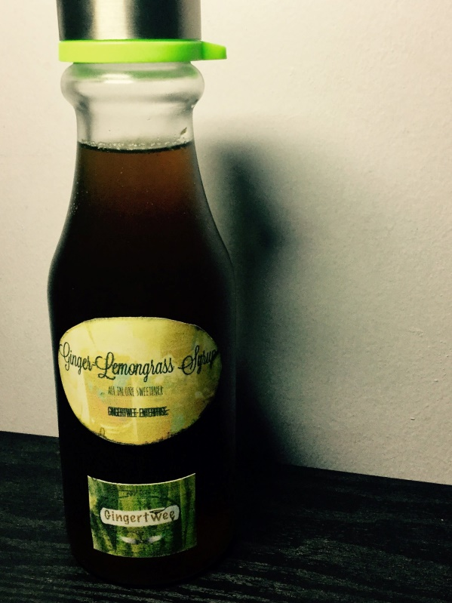
Figure 2: The Product GINGER-LEMONGRASS FLAVORED SYRUP
2. Price
The demand and supply of any commodity in the market will be based on the effects of the product’s price and quality. That is why having a new product, the proponents agreed to establish a price that is affordable to most consumers being worthy of its value and quality. The price of the product will be Php 60.00 for every 375mL.
3. Place
The location of the business will be in Baguio City since the proponents are students of SLU-Baguio and residents of the city. The proponents also believed that the city will be an ideal target market for the product, because of its potential demand and availability of raw materials for the product. The place of the production site is located at Unit A, located in No.17 Bonifacio Street, A. Bonifacio-Caguioa-Rimando, Baguio City. The Gingertwee Enterprise will be distributing its product to different supermarkets, grocery stores, small independent (“sari-sari”) stores around Baguio City.
4. Promotion
To effectively advertise our product, GINGER-LEMONGRASS SYRUP, the proponents will conduct marketing strategies such as the distribution of leaflets in to different public places in Baguio; this will incur lesser cost for the enterprise. An official Facebook page in social media will also take part as a promotional strategy. Both leaflets and Facebook page will contain information about the logo, name, location, contact information and the official motto of the enterprise.

Figure 3: Sample Leaflet

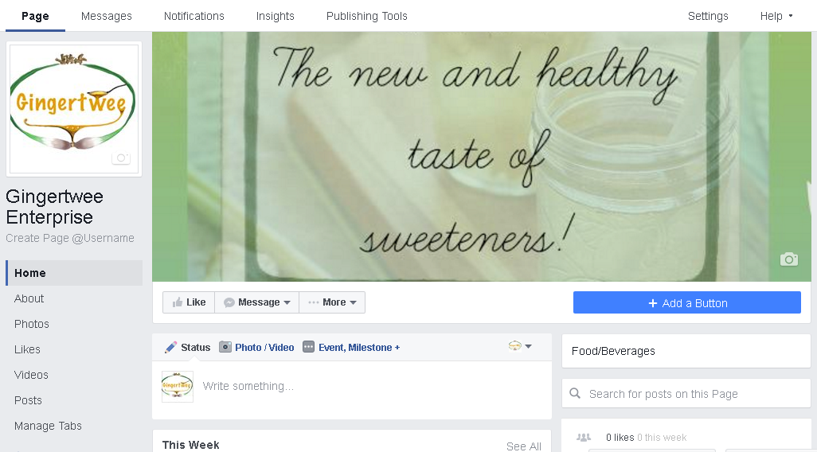Figure 4: Official Facebook Page

CHAPTER III
TECHNICAL STUDY
Introduction
The technical study presents the business operation of the enterprise in a detailed manner. This chapter determines the startup capital that includes the raw materials, equipment, supplies and utilities, and the production schedule, production cost, project cost and labor requirement to facilitate its operation.
The proponents have assessed the availability of the resources needed and also the location of production of the product. There are different factors to consider on choosing the location which are social, economic and technological factors that may affect the marketability of the product.
- The Product
Syrup is a condiment that is a thick, viscous liquid for cooking and mixed in the beverages. It is usually used as a flavoring agent for food. It consist of a solution of sugar in water, containing a large amount of dissolved sugars but showing little tendency to deposit crystals. The proponents thought of an additional flavor to add on a sweetener and came with various ingredients such as ginger and lemongrass. Thus, began the Ginger-Lemongrass syrup.
The Ginger Lemongrass Syrup is generally brown in color. The product taste sweet at its first taste and a little bit of spicy flavor that gives a menthol feeling in your throat because of the ingredient ginger. It is safe and healthy because it is made naturally without using chemicals or preservatives. The main ingredients of the product are ginger and lemongrass that are very beneficial to our body because of the health benefits it has. The packaging material is a plastic bottle in which it can be recycled and it is 375ml.
- Manufacturing Process
The enterprise will repeat the production process twice a day. In one production process, the enterprise can produce 50 bottles of 375ml Ginger Lemongrass Syrup.
Ingredients:
- Ginger (4.75kg)
- Lemongrass (2.7kg)
- Brown sugar (4.75kg)
- Water (2 liter)
1. The Preparation of Ingredients (15 minutes)
The ingredients will be prepared. In this process, it includes the rinsing of ginger and lemongrass, slicing the ginger into dice with the use of a knife and a chopping board, and cutting the lemongrass into strips using scissors. The preparation of other materials like the casserole, measuring cup and other materials in making the product are also included in this process.
2. Extraction of ginger and lemongrass (30 minutes)
After all the materials are prepared, put one liter of water into the large casserole and add 2.37 kilograms of diced ginger into the casserole. Heat the mixture on the stove. Let it simmer for 20-30 minutes until the water is golden brown. This will be repeated five times due to the capacity of the casserole.
3. Mixing all of the ingredients (30 minutes).
After extracting the ginger and lemongrass juice, put the 2.37 kilograms of sugar into the casserole. Stir it with a spatula constantly until the brown sugar is fully dissolves. Continually stir the mixture and let it boil for about 5 minutes until the mixture thickens.
4. Cooling of the mixture (45 minutes)
Let the mixture sit for 45 minutes.
5. Packaging (1 hour and 30 minutes)
The proponents have decided to produce 45 pieces of 375ml bottle of Ginger Lemongrass Syrup per production. After cooling the mixture, use a funnel in transferring the mixture into the 375 ml bottle. In this process it will include putting the stickers of the product.

- Production Flowchart
Preparation of Ingredients
(15 minutes)

Production and Distribution Staff

Mixing all the ingredients
(30 minutes)

Cooling of the mixture
(45 minutes)

Packaging (1 hour and 30 minutes)
Total: 3 hours and 30 minutes
D. Plant Size and Production Schedule
The plant size is design to accommodate all the tools, supplies, equipment, and production area and storage room. It is located at Unit A, located in No.17 Bonifacio Street, A. Bonifacio-Caguioa-Rimando, Baguio, Benguet. The Gingertwee enterprise will rent a commercial space.
The enterprise will be open at 8:00 am and will be closed at 5:00pm. All laborers will have a lunch break from 12:00 noon to 1:00pm, a ten minute break in the morning and ten minutes cleaning time before 5:00 pm. The enterprise will operate all year round, except Sundays, and special or regular holidays. The managing partners will regularly check all the facilities of the production site and the raw materials and inventories stored therein.
E. Machineries and Equipment
1. LPG Tank with Refill  Brand Name:  Petron Gasul  Weight:  11kilograms  Where to buy:  Tiongsan Harrison  Cost per Unit: Php 2,080.00  No. of Unit/s: 2  Total Cost: Php 4,160.00 | 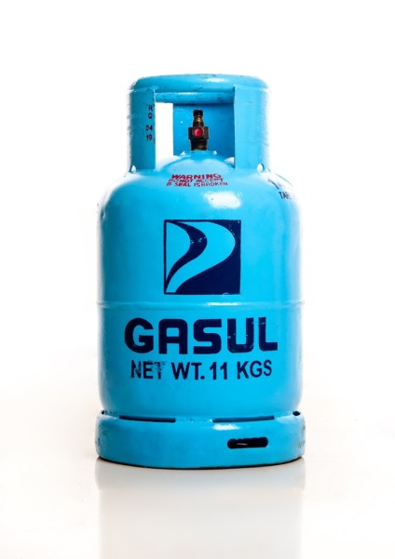
2. Gas Stove Pressure Regulator  Where to buy:  Tiongsan Harrison  Cost per unit: Php 170.00  No. of unit/s: 1  Total cost: Php 170.00 | 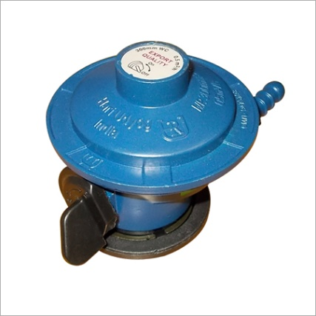
3. Propane Hose  Where to buy:  Tiongsan Harrison  Cost per unit: Php 170.00  No. of unit/s: 1  Total cost: Php 170.00 | 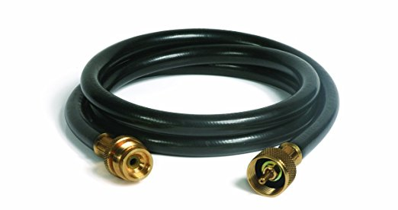

4. Stove  Brand name: 3D New Generation  Where: SM Appliances Baguio  Cost per unit: Php 1,499.75  No. of unit/s: 1  Total cost: Php1,499.75 | 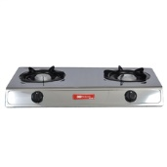
6. Heat Gun or Sealer ghg 600-3  Brand: Bosch  Cost per unit: Php 1,000.00  No. of unit/s: 1  Where to buy: Tiongsan  Total cost: Php 1,000 | 

F. Plant Location
The production site would be at No.17 Bonifacio Street, A. Bonifacio-Caguioa-Rimando, Baguio, Benguet. The renting expenses a month will be Php 15,000. The proponents decided this place as the enterprise’s production area, since it is very near the Public Market and the delivery of the products will be convenient because most suppliers of syrups in the city are very near the production area as well.
G. Vicinity Map
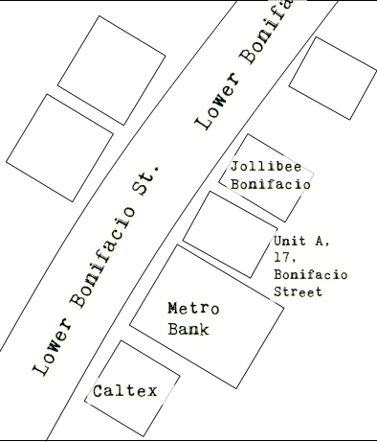
Figure 4: Vicinity Map of Production Area

H. Production Site
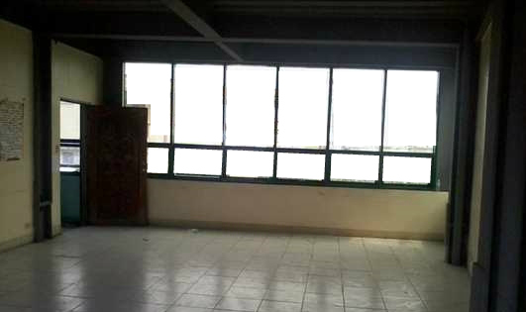
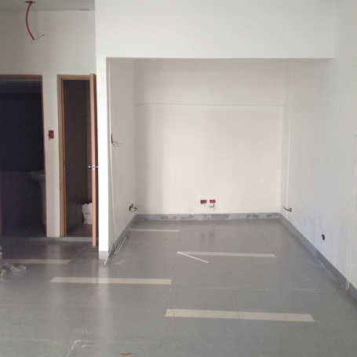
Figure 5: Image of the Production Area
I. Plant Layout
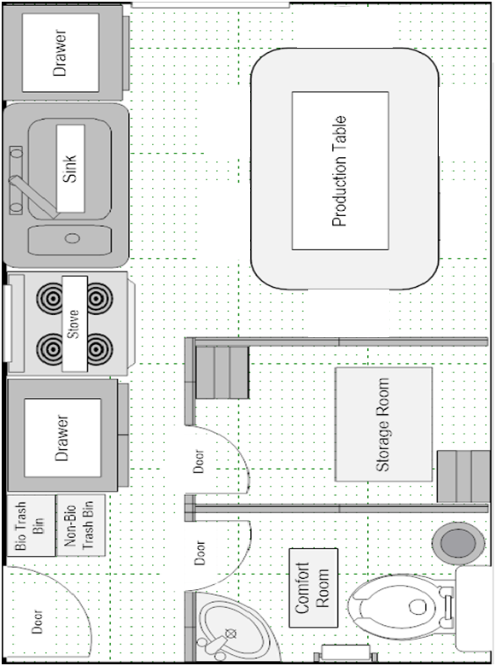
2 m
5 m

Figure 6: Floor Plan
5 m
J. Raw Materials and Supply
Monthly Raw Materials
Items | Unit Cost | Quantity | Total
Ginger | Php200.00/kg | 228kg | Php45,600.00
Lemongrass | 60.00/kg | 132kg | 7,920.00
Brown Sugar | 40.00/kg | 228kg | 9,120.00
Total Raw Materials |  |  | Php62,640.00
Freight Cost of Ginger and Lemongrass |  |  | 1,600.00
Total Cost of Raw Materials Daily |  |  | Php64,240.00

Production Tools
Items | Unit Cost | Quantity | Total
Measuring cups | Php119.00 | 1 | Php119.00
Knife | 229.75 | 2 | 459.75
Chopping board | 79.75 | 2 | 159.75
Spatula | 49.75 | 2 | 99.75
Strainer | 119.75 | 2 | 239.50
Basin (Large Stainless) | 495.00 | 1 | 495.00
Casserole | 1,749.75 | 2 | 3,499.50
Funnel (Set) | 199.75 | 2 | 399.50
Total Cost of Production Tools |  |  | Php5,471.00

Production Supplies
Items | Unit Cost | Quantity | Total
Apron | Php50.00 | 2 | Php100.00
Hairnet | 10.00 | 2 | 20.00
Disposable Gloves (box that contains 100 pieces) | 40.00 | 1 | 40.00
Face Masks (box that contains 20 pieces) | 160.00 | 1 | 160.00
Total Cost of Production Supplies |  |  | Php320.00

Packaging Supplies
Items | Unit cost | Quantity | Total
Plastic Bottle | Php20.00 | 100 | Php2,000.00
Printed Sticker (1 Sticker Paper 10 pcs. of Stickers) | 4.00 | 10 | 40.00
Printed Price Tag (1 Sticker Paper 30 pcs. of Price tags) | 4.00 | 3 | 12.00
Total Cost of Packaging Supplies Monthly |  |  | Php2,052.00

Cleaning Supplies
Items | Unit Cost | Quantity | Total
Soft Broom | Php100.00 | 1 | Php100.00
Dust Pan | 250.00 | 1 | 250.00
Floor Mop | 160.00 | 1 | 160.00
Trash Can | 100.00 | 1 | 100.00
Dishwashing Liquid (500mL) | 65.00 | 2 | 130.00
Scotch Brite with sponge | 44.75 | 2 | 89.50
Garbage Bags | 150.00 | 1 | 150.00
Hand Towel | 15.00 | 2 | 30.00
Rags | 49.75 | 2 | 99.50
Total Cost of Cleaning Supplies |  |  | Php1,109

Office Supplies
Items | Unit Cost | Quantity | Total
Calculator | Php350.00 | 1 | Php350.00
Record Book | 80.00 | 1 | 80.00
Official Receipt | 25.00 | 20 | 500.00
Journal | 60.00 | 1 | 60.00
Voucher | 65.00 | 2 | 130.00
HBW ballpen | 6.00 | 3 | 18.00
Stapler | 60.00 | 1 | 60.00
Staple Wire(Box) | 35.00 | 1 | 35.00
Scissor | 25.00 | 2 | 50.00
Marker | 18.00 | 3 | 54.00
Wall Clock | 150.00 | 1 | 150.00
Battery | 140.00 | 1 | 140.00
Paper Clip | 30.00 | 1 | 30.00
Total Cost of Office Supplies |  |  | Php1,657
Other Supplies
Items | Unit Cost | Quantity | Total
Fire Extinguisher | Php2,000.00 | 1 | Php2,000.00
Total Other Supplies |  |  | Php2,000.00

K. Utilities
The Gingertwee Enterprise will need the availability of basic services such as water, electricity, gas and communication expense in its operation and production of Ginger-Lemongrass Syrup.
1. Water Consumption
The Baguio Water District will be the source of water supply. Water is necessary for washing the raw materials to be used, keeping the cleanliness of the production area, and for maintaining personal hygiene.
Water Consumption
Average Monthly Consumption | 5
Price Per Cubic Meter | 70.00
Monthly Water Consumption | 350.00
Divide By: Number of Working Days | 24
Total Water Consumption Daily | 14.58

2. Electricity Consumption
Electricity is a significant form of energy for small and medium, and large-scale businesses. The enterprise will utilize electricity mainly for the lighting of the production area and for charging personal electronic gadgets.
Electricity Consumption
Items | Quantity | Hours Used | kwh | Commercial Rate | Total Consumption
Light Bulb | 2 | 8 | 0.018 | 6.9063 | Php1.9890
Cellphone Charger | 1 | 1 | 1.00 | 6.9063 | 6.9063
Heat Gun | 1 | 4.5 | 0.002 | 6.9063 | 0.0621
Total Electric Consumption Daily |  |  |  |  | Php8.96

3. Liquid Petroleum Gas (LPG)
The proponents will be purchasing 11 kg of LPG Tank worth P2,080.00 each which will be consumed for a month of operation. The average price price for refilling the LPG Tank will be P580.00 Tank a month.
Liquid Petroleum Gas (LPG) Expense
Gas Refill | Php580.00
Quantity | 1
Total LPG Expense | 580.00
Divide by: Number of Working Days | 24
Total LPG Expense Daily | Php24.1666667

L.Waste Disposal
The enterprise will be applying its Corporate Social Responsibilities through its Proper Waste Management System. The system will be having more of its waste segregation, having both biodegradable and non-biodegradable trash bins in the production area. The proponents will be mindful of disposing wastes properly in an area along the way of Bonifacio Street as mandated by the Administration of Wastes for garbage collection, and will also note on the scheduled days of collection in the area.
M. Labor Requirements
For the enterprise to perform efficiently with their operation, the proponents would need at least two (2) employees who will be receiving trainings to take responsibilities over the purchase of raw materials, the production process of the enterprise and the delivery of the finished products. The employees will be purchasing raw materials, processing these raw materials, producing about 90 bottles of syrup twice a month, and after which, delivering the products to the suppliers of syrup in the city. From washing and cleaning the raw materials, manually peeling and chopping the ingredients, checking the correct boiling temperature of sugar syrup, adding the main ingredients, measuring and packaging the final product, and maintaining proper waste management in the area will be under the responsibilities of the employees on its production process. As for a starter in business, the daily wage will be Php 285.00 since it is the current minimum wage here in Baguio City. Upon acceptance for the job, the two (2) employees shall receive this benefit including SSS, Philhealth, PAGIBIG and 13th month pay.
Operations will start at 8 A.M. and will end at 5 P.M., for a total of 8 working hours for the employees. They are required to be early in the production building and start working at the exact starting time of work. The employees will be given a 15-minute break in the morning (10:00-10:15 A.M.), an hour lunch break (12:00noon-1:00pm), and another 15-minute break in the afternoon. The days of work will only be Mondays until Saturdays only. Constituting factors such as responsibility and honesty towards work will allow employees to secure their jobs and establish the enterprise’s trust and confidence on their job performances.
N. Production Cost
Particulars | Note | Amount
Raw Materials | 1 | Php1,369.00
Direct Labor | 2 | 677.98
Factory Overhead | 3 | 2,533.70
Total |  | Php4,580.68
Divide by: Bottle produced |  | 100
Cost Per Unit |  | 45.81
Add: Mark-up (30%) |  | 13.743
Selling Price per bottle |  | Php59.55

Note1: Raw Materials
Items | Unit Cost | Quantity | Total
Ginger | Php200.00/kg | 4.75kg | Php950.00
Lemongrass | 60.00/kg | 2.70kg | 162.00
Brown Sugar | 40.00/kg | 4.75kg | 190.00
Total Raw Materials |  |  | Php1,302.00
Freight Cost of Ginger and Lemongrass |  |  | 67.00
Total Cost of Raw Materials Daily |  |  | Php1,369.00

Note2: Direct Labor
Minimum Wage (Php285*2) | Php570.00
Multiply by: Number of working days | 24
Total Monthly Salaries | 13,680.00
Add: Benefits of Employees
SSS(Php525.70*2) | 1,501.40
Philhealth(Php100.00*2) | 200.00
PAGIBIG(Php100.00*2) | 200.00
13th Month Pay(Php6,840.00*2)/12 | 1,140.00
Total Labor Cost Monthly | 16,271.40
Divide by: Number of Working Days | 24
Total Labor Cost Daily | 677.98

Schedule 1: Rent Expense
Rent Expense Monthly | Php10,000.00
Divide by: Number of Working Days | 24
Total Rent Expense Daily | Php417.00

Schedule 2: Water Consumption
Average Monthly Consumption | 5
Price Per Cubic Meter | 70.00
Monthly Water Consumption | 350.00
Divide By: Number of Working Days | 24
Total Water Consumption Daily | 14.58

Schedule 3: Electricity Consumption
Items | Quantity | Hours Used | Kwh | Commercial Rate | Total Consumption
Light Bulb | 2 | 8 | 0.018 | 6.9063 | Php1.9890
Cellphone Charger | 1 | 1 | 1.00 | 6.9063 | 6.9063
Bottle Cap Sealer | 1 | 4.5 | 0.002 | 6.9063 | 0.0621
Total Electric Consumption Daily |  |  |  |  | Php8.9574

Schedule 4: Communication Expense
Monthly Expense | Php250.00
Divide by: Number of Working Days | 24
Total Communication Expense Daily | Php10.42

Schedule 5: LPG Expense
Gas Refill | Php580.00
Quantity | 1
Total LPG Expense | 580.00
Divide by: Number of Working Days | 24
Total LPG Expense Daily | Php24.1666667

Schedule 6: Packaging Supplies
Items | Unit cost | Quantity | Total
Plastic Bottle | Php20.00 | 2400 | Php48,000.00
Printed Sticker ( 1 Sticker Paper 10 pcs of Stickers ) | 4.00 | 240 | 960.00
Printed Price Tag ( 1 Sticker Paper 30 pcs of Price tags) | 4.00 | 80 | 320.00
Total Cost of Packaging Supplies Monthly |  |  | Php49,280.00
Number of Production days a month |  |  | 24
Daily Cost of Packaging Supplies |  |  | 2,054.00

Schedule 7: Production Supplies
Items | Unit Cost | Quantity | Total
Apron | Php50.00 | 2 | Php100.00
Hairnet | 10.00 | 2 | 20.00
Disposable Gloves (box that contains 100 pieces) | 40.00 | 1 | 40.00
Face Masks (box that contains 20 pieces) | 160.00 | 1 | 160.00
Total Cost of Production Supplies |  |  | Php320.00
Divided by: No. of Production days a month |  |  | 24
Daily Cost of Production Supplies |  |  | Php13.33

Note3: Factory Overhead
Expenses | Schedule | Amount
Rent Expense | 1 | Php417.00
Water Consumption | 2 | 14.58
Electricity Consumption | 3 | 8.96
LPG Expense | 5 | 25.83
Packaging Supplies | 6 | 2,054.00
Production Supplies | 7 | 13.33
Total |  | Php2,533.70

O. Project Cost
Accounts | Note | Cost
Raw Materials | 1 | Php64,240.00
Machineries and Equipment | 2 | 7,000.00
Office Supplies | 3 | 1,657.00
Packaging Supplies | 4 | 49,280.00
Cleaning Supplies | 5 | 1,109.00
Production Tools | 6 | 5,471.00
Production Supplies | 7 | 320.00
Other Supplies | 8 | 2,000.00
LPG Consumption | 9 | 580.00
Electric Consumption | 10 | 214.98
Water Consumption | 11 | 350.00
Advertising Expense | 12 | 100.00
Direct Labor | 13 | 677.98
Furniture and Fixtures | 14 | 12,300.00
Delivery Expense | 15 | 2,400.00
Renovation Costs | 16 | 5,335.00
Feasibility Cost | 17 | 2,800.00
Rent Expense | 18 | 10,000.00
Prepaid Rent | 19 | 15,000.00
Taxes and Licenses | 20 | 5,480.60
Total Project Cost |  | 186,315.56
Add: Contingency Fund |  | 23,684.44
Total Investment Cost |  | 210,000.00

Note1: Raw Materials
Items | Unit Cost | Quantity | Total
Ginger | Php200.00/kg | 228kg | Php45,600.00
Lemongrass | 60.00/kg | 132kg | 7,920.00
Brown Sugar | 40.00/kg | 228kg | 9,120.00
Total Raw Materials |  |  | Php62,640.00
Freight Cost of Ginger and Lemongrass |  |  | 1,600.00
Total Cost of Raw Materials Daily |  |  | Php64,240.00

Note2: Machineries and Equipment
Items | Unit Cost | Quantity | Total
LPG Gas Tank | 2,080.00 | 2 | 4,160.00
Gas Stove Pressure Regulator | 170.00 | 1 | 170.00
Propane Hose | 170.00 | 1 | 170.00
Stove | 1,499.75 | 1 | 1,499.75
Heat Gun | 1,000.00 | 1 | 1,000
Total Cost of Machineries And Equipment |  |  | Php7,000.00

Note3: Office Supplies
Items | Unit Cost | Quantity | Total
Calculator | Php350.00 | 1 | Php350.00
Record Book | 80.00 | 1 | 80.00
Official Receipt | 25.00 | 20 | 500.00
Journal | 60.00 | 1 | 60.00
Voucher | 65.00 | 2 | 130.00
HBW ballpen | 6.00 | 3 | 18.00
Stapler | 60.00 | 1 | 60.00
Staple Wire(Box) | 35.00 | 1 | 35.00
Scissor | 25.00 | 2 | 50.00
Marker | 18.00 | 3 | 54.00
Wall Clock | 150.00 | 1 | 150.00
Battery | 140.00 | 1 | 140.00
Paper Clip | 30.00 | 1 | 30.00
Total Cost of Office Supplies |  |  | Php1,657.00

Note4: Packaging Supplies
Items | Unit cost | Quantity | Total
Plastic Bottle | Php20.00 | 2400 | Php48,000.00
Printed Sticker ( 1 Sticker Paper 10 pcs of Stickers ) | 4.00 | 240 | 960.00
Printed Price Tag ( 1 Sticker Paper 30 pcs of Price tags) | 4.00 | 80 | 320.00
Total Cost of Packaging Supplies Monthly |  |  | Php49,280.00

Note5: Cleaning Supplies
Items | Unit Cost | Quantity | Total
Soft Broom | Php100.00 | 1 | Php100.00
Dust Pan | 250.00 | 1 | 250.00
Floor Mop | 160.00 | 1 | 160.00
Trash Can | 100.00 | 1 | 100.00
Dishwashing Liquid (500mL) | 65.00 | 2 | 130.00
Scotch Brite with sponge | 44.75 | 2 | 89.50
Garbage Bags | 150.00 | 1 | 150.00
Hand Towel | 15.00 | 2 | 30.00
Rags | 49.75 | 2 | 99.50
Total Cost of Cleaning Supplies |  |  | Php1,109.00

Note6: Production Tools
Items | Unit Cost | Quantity | Total
Measuring cups | Php119.00 | 1 | Php119.00
Knife | 229.75 | 2 | 459.75
Chopping board | 79.75 | 2 | 159.50
Spatula | 49.75 | 2 | 99.50
Strainer | 119.75 | 2 | 239.50
Basin (Large Stainless) | 495.00 | 1 | 495.00
Casserole | 1,749.75 | 2 | 3,499.50
Funnel (Set) | 199.75 | 2 | 399.50
Total Cost of Production Tools |  |  | Php5,471.00

Note7: Production Supplies
Items | Unit Cost | Quantity | Total
Apron | Php50.00 | 2 | Php100.00
Hairnet | 10.00 | 2 | 20.00
Disposable Gloves (box that contains 100 pieces) | 40.00 | 1 | 40.00
Face Masks (box that contains 20 pieces) | 160.00 | 1 | 160.00
Total Cost of Production Supplies |  |  | Php320.00

Note8: Other Supplies
Items | Unit Cost | Quantity | Total
Fire Extinguisher | Php2,000.00 | 1 | Php2,000.00
Note9: LPG Consumption
Gas Refill | Php580.00
Quantity | 1
Total LPG Expense | 580.00

Note10: Electric Consumption
Items | Quantity | Hours Used | kwh | Commercial Rate | Total Consumption
Light Bulb | 2 | 8 | 0.018 | 6.9063 | Php1.9890
Cellphone Charger | 1 | 1 | 1.00 | 6.9063 | 6.9063
Heat Gun | 1 | 4.5 | 0.002 | 6.9063 | 0.0621
Total Electric Consumption Daily |  |  |  |  | Php8.9574
Multiply by: Number of Production Days |  |  |  |  | 24
Total Electric Monthly Consumption |  |  |  |  | Php214.98

Note11: Water Consumption
Average Monthly Consumption (In Cubic Meter) | 5
Multiply by: Price per Cubic Meter | 40.50
Water Consumption Monthly | Php202.50
Fixed Price of BAWADI below 10 cubic meter | Php 350.00

Note12: Communication Expense
Monthly Load Expense | Php300.00
Note13: Advertising Expense
Items | Unit Cost | Quantity | Total
Leaflets (8 pcs) | Php10.00 | 10 | Php100.00
Total Advertising Expense |  |  | Php100.00

Note14: Direct Labor
Minimum Wage (Php285*2) | Php570.00
Multiply by: Number of working days | 24
Total Monthly Salaries | 13,680.00
Add: Benefits of Employees
SSS(Php525.70*2) | 1,501.40
Philhealth(Php100.00*2) | 200.00
PAGIBIG(Php100.00*2) | 200.00
13th Month Pay(Php6,840.00*2)/12 | 1,140.00
Total Labor Cost Monthly | 16,271.40
Divide by: Number of Working Days | 24
Total Labor Cost Daily | 677.98

Note15: Furniture and Fixtures
Items | Unit Cost | Quantity | Total
Office Chair | 350.00 | 1 | 350.00
Filing Cabinet | 1,000.00 | 1 | 1,000.00
Table | 1,200.00 | 1 | 1,200.00
Stainless Production Table | 9,000.00 | 1 | 9,000.00
Production Chair | 150.00 | 5 | 750.00
Total Furniture and Fixture Cost |  |  | Php12,300.00

Note16: Delivery Expense
Delivery Expense per Day | Php100.00
Multiply by: Number of Working Days | 24
Monthly Delivery Expense | Php2,400.00

Note17: Renovation Expense
Items | Unit Cost | Quantity | Total
Paint Brush | 30.00 | 2 | Php60.00
Boysen Paint | 510.00 | 2 Gallons | 1,020.00
Thinner | 60.00 | 1 Bottle | 60.00
Labor Cost For 1 Carpenter(400*3 Days) |  |  | 1,200.00
Sand And Gravel(Per Bag) | 25.00 | 5 | 125.00
Cement | 220.00 | 2 | 440.00
Hollow Blocks | 12.00 | 15 | 180.00
Steel Bars(10mm) | 110.00 | 5 | 550.00
Wood(2x3) | 120.00 | 5 | 600.00
Faucet | 100.00 | 1 | 100.00
Plywood(1/4) | 350.00 | 2 | 700.00
Light Bulbs | 300.00 | 1 | 300.00
Total Renovation Cost |  |  | Php5,275.00

Note18: Feasibility Cost
Item | Total Cost
Book Bind | Php1,500.00
Printing | 500.00
Transportation | 100.00
Photocopy | 700.00
Total Feasibility Expense | Php2,800.00

Note19: Rent Expense
Monthly Rent Expense | 15,000.00

Note20: Prepaid Rent
One month advance | 15,000.00

Note21: Taxes and Licenses
Taxes and Licenses | Cost
Business Permits:
Barangay Business Clearance | Php250.00
Initial Tax | 180.00
Mayor’s Permit | 150.00
Sanitary Business Fee | 100.00
Tax Clearance/Certification Fees | 100.00
Fire Inspection Fee | 45.00
Sanitary Inspection Fee | 125.00
Sewer Connection Fee | 600.00
Business Plate | 150.00
Garbage Fee | 300.00
Cedula | 5.60
Total Business Permit | 2,005.60
Payment for BIR:
Certification Fee | 100.00
Registration | 500.00
Documentary Satmp | 100.00
Book | 50.00
Total BIR Payment | 750.00
Payments for SEC:
Name Reservation Fee | 125.00
Notarial Fees | 1,500.00
Registration Fee | 1,000.00
Documentary Stamp | 50.00
Forms | 50.00
Total SEC Payment | 2,725.00
Total Taxes and Licenses | Php5,480.60

CHAPTER IV
FINANCIAL STUDY
Introduction
The Financial Study of the business determines whether the project is viable in meeting its long-term and short-term obligations, as well as whether the enterprise will be profitable even with existing competition and present detailed figures to show the improvement of the project’s financial condition over time. This Chapter includes the major assumptions, schedules and notes for the financial statements in next five years of operation of the enterprise.
A. Major Assumptions
1. Annual Production Days
The operation of the business will start on January 1, 2017. For the first year, the enterprise will operate for 288 days. The production will be eight (8) hours a day from 8 A.M. to 5 P.M. The total of workdays in a year will be 288 days in which holidays and Sundays are excluded. The 288 days will be constant for the next four years of operation of the enterprise.
2. Production
It is expected that the enterprise will produce 100 bottles per day having a total of 28,800 bottles for the first year. The production of the enterprise will increase by 8% every year.
3. Sales
The sales would be on consignment basis. The delivery of the product will be on a monthly basis. The receivable from the consignee would be the last week of the year delivery.
4. Selling Price
The product will be sold for Php70.00 per bottle inclusive of a 75% markup on the first year. The selling price will increase by 5% every year due to inflation and will be round off into the nearest centavo.
5. Raw Materials
The raw materials needed for the production will be purchased monthly and paid through cash. The proponents will assume a 8% increase annually due to increase in production quantity.
6. Packaging Supplies
The packaging supplies of the enterprise would increase by 8% annually.

7. Supplies
The enterprise will consider a 2% increase for the price of different supplies such as for the office supplies, cleaning supplies, and production supplies.
8. Rent Expense
The rent expense is constant since it is has been agreed between the partners and the owner of the commercial space.
9. Delivery Expense
The delivery expense is assumed Php 2,400.00 monthly not subject to yearly changes since fare does not increase yearly.
10. Advertising Expense
The advertising expense in the first year is Php1,000.00 while the next four years will be decreased by 8%.
11. Utilities Expense
Cost of utilities will not be subjected to changes for the succeeding 5 years.
12. Depreciation
The Straight Line Method of Depreciation will be used for computing the depreciation of all depreciable assets. The estimated useful life will be five (5) years.

13. Partner’s Contribution
Each member will contribute Php 50,000 for the start-up capital of the enterprise. There will be an equal distribution, among the partners, of both profits and losses incurred.
14. Withdrawals
Each partner is allowed to withdraw up to 30% in the share of their net income.
15. Salaries Expense
The enterprise will provide the minimum wage of Php 285.00 per employees, as well as SSS, Philihealth, and Pag-ibig benefits.
16. Bonus
A bonus equal to an employee’s one-month salary will be given as a 13th month pay.
17. Inventory, ending
The product for the last day of production will be a part of the ending inventory as assumed to be delivered but not yet sold.
THE GINGERTWEE ENTERPRISE
Projected Income Statement
For the Years Ended December 31, 2017-2021
 | Notes | 2017 | 2018 | 2019 | 2020 | 2021
Net Sales | 1 | 2,009,000.00 | 2,278,206.00 | 2,583,485.60 | 2,929,672.67 | 3,322,248.81
Less: Cost of Goods Sold | 2 | 1,691,111.26 | 1,785,279.05 | 1,902,370.48 | 2,019,913.07 | 2,155,803.51
Gross Profit |  | 317,888.74 | 492,926.95 | 681,115.13 | 909,759.61 | 1,166,445.30
Less: Operating Expenses | 3 | 17,712.60 | 4,277.74 | 4,293.98 | 4,311.29 | 4,329.61
Earnings Before Tax |  | 300,176.14 | 488,649.21 | 676,821.14 | 905,448.32 | 1,162,115.69
Less: Income Tax (30%) |  | 90,052.84 | 146,594.76 | 203,046.34 | 271,634.50 | 348,634.71
Net Income After Tax |  | 210,123.30 | 342,054.45 | 473,774.80 | 633,813.82 | 813,480.98

Note 1: Net Sales
 | Schedule | 2017 | 2018 | 2019 | 2020 | 2021
Annual Production | 1 | 28,800.00 | 31,104.00 | 33,592.32 | 36,279.71 | 39,182.08
Less: Inventory, ending |  | 100 | 108 | 117 | 126 | 136
Total |  | 28,700.00 | 30,996.00 | 33,475.68 | 36,153.73 | 39,046.03
Multiply by: Selling Price |  | 70.00 | 73.50 | 77.18 | 81.03 | 85.09
Net Sales |  | 2,009,000.00 | 2,278,206.00 | 2,583,485.60 | 2,929,672.67 | 3,322,248.81

Note 2: Cost of Goods Sold
 | Schedule | 2017 | 2018 | 2019 | 2020 | 2021
Raw Materials | 2 | 753,280.00 | 813,414.40 | 878,359.55 | 948,500.32 | 1,024,252.34
Direct Labor | 3 | 164,160.00 | 164,160.00 | 164,160.00 | 164,160.00 | 164,160.00
Employee Benefits | 4 | 36,496.80 | 36,496.80 | 36,496.80 | 36,496.80 | 36,496.80
Factory Overhead | 5 | 737,174.46 | 771,207.85 | 823,354.12 | 870,755.95 | 930,894.37
Cost of Goods Sold |  | 1,691,111.26 | 1,785,279.05 | 1,902,370.48 | 2,019,913.07 | 2,155,803.51

Note 3: Operating Expense
 | Schedule | 2017 | 2018 | 2019 | 2020 | 2021
Office Supplies | 17 | 1,657.00 | 1,180.14 | 1,203.74 | 1,227.82 | 1,252.37
Taxes and Licenses | 18 | 5,480.60 | 605.60 | 605.60 | 605.60 | 605.60
Feasibility Cost | 19 | 2800 | - | - | - | -
Advertising Expense | 20 | 100.00 | 92.00 | 84.64 | 77.87 | 71.64
Delivery Expense | 21 | 2400 | 2400 | 2400 | 2400 | 2400
Renovation Cost | 22 | 5,275.00 | - | - | - | -
Total Operating Expense |  | 17,712.60 | 4,277.74 | 4,293.98 | 4,311.29 | 4,329.61
Schedule 1: Annual Production
 |  | 2017 | 2018 | 2019 | 2020 | 2021
Daily Production |  | 100 | 108 | 116.64 | 125.9712 | 136.048896
Multiply by: Production Days |  | 288 | 288 | 288 | 288 | 288
Annual Production |  | 28,800.00 | 31,104.00 | 33,592.32 | 36,279.71 | 39,182.08

Schedule 2: Raw Materials
 | 2017 |  | 2018 |  | 2019 |  |  | 2020 |  | 2021
Ginger | 547,200.00 |  | 590,976.00 |  | 638,254.08 |  |  | 689,314.41 |  | 744,459.56
Lemongrass | 95,040.00 |  | 102,643.20 |  | 110,854.66 |  |  | 119,723.03 |  | 129,300.87
Brown Sugar | 109,440.00 |  | 118,195.20 |  | 127,650.82 |  |  | 137,862.88 |  | 148,891.91
Total Raw Materials | 751,680.00 |  | 811,814.40 |  | 876,759.55 |  |  | 946,900.32 |  | 1,022,652.34
Freight Cost of Ginger and Lemongrass | 1,600.00 |  | 1,600.00 |  | 1,600.00 |  |  | 1,600.00 |  | 1,600.00
Total Cost of Raw Materials | 753,280.00 |  | 813,414.40 |  | 878,359.55 |  |  | 948,500.32 |  | 1,024,252.34
Schedule 3: Direct Labor
 | 2017 |  | 2018 |  | 2019 |  | 2020 |  |  | 2021
Minimum Wage | 285.00 |  | 285.00 |  | 285.00 |  | 285.00 |  |  | 285.00
Multiply by: Production Days | 288 |  | 288 |  | 288 |  | 288 |  |  | 288
Salary per worker | 82,080.00 |  | 82,080.00 |  | 82,080.00 |  | 82,080.00 |  |  | 82,080.00
Multiply by: No. of workers | 2 |  | 2 |  | 2 |  | 2 |  |  | 2
Total Direct Labor | 164,160.00 |  | 164,160.00 |  | 164,160.00 |  | 164,160.00 |  |  | 164,160.00

Schedule 4: Employee Benefits
 |  | 2017 | 2018 | 2019 | 2020 | 2021
SSS |  | 18,016.80 | 18,016.80 | 18,016.80 | 18,016.80 | 18,016.80
PhilHealth |  | 2,400.00 | 2,400.00 | 2,400.00 | 2,400.00 | 2,400.00
PAG-IBIG |  | 2,400.00 | 2,400.00 | 2,400.00 | 2,400.00 | 2,400.00
13th Month Pay |  | 13,680.00 | 13,680.00 | 13,680.00 | 13,680.00 | 13,680.00
Total Employee Benefits |  | 36,496.80 | 36,496.80 | 36,496.80 | 36,496.80 | 36,496.80

Schedule 5: Factory Overhead
 | Schedule | 2017 | 2018 | 2019 | 2020 | 2021
Packaging Supplies | 6 | 579,840.00 | 626,227.20 | 676,325.38 | 725,594.11 | 783,641.64
Production Supplies | 7 | 2520.00 | 510.00 | 2478.60 | 530.60 | 2538.78
Other Supplies | 8 | 2000.00 | - | - | - | -
Cleaning Supplies | 9 | 4666.50 | 3974.94 | 4054.44 | 4135.53 | 4218.24
Rent Expense | 10 | 120000.00 | 120000.00 | 120000.00 | 120000.00 | 120000.00
Water Consumption | 11 | 4200.00 | 4200.00 | 4200.00 | 4200.00 | 4200.00
Electricity Consumption | 12 | 2579.76 | 2579.76 | 2579.76 | 2579.76 | 2579.76
Communication Expense | 13 | 3600.00 | 3600.00 | 3600.00 | 3600.00 | 3600.00
LPG Expense | 14 | 9,040.00 | 6,960.00 | 6,960.00 | 6,960.00 | 6,960.00
Depreciation Expense | 15 | 3155.95 | 3155.95 | 3155.95 | 3155.95 | 3155.95
Production Tools | 16 | 5,572.25 | - | - | - | -
Total Factory Overhead |  | 737,174.46 | 771,207.85 | 823,354.12 | 870,755.95 | 930,894.37

Schedule 6: Packaging Supplies
 | 2017 | 2018 |  |  | 2019 |  | 2020 |  | 2021
Plastic Bottle | 576,000.00 | 622,080.00 |  |  | 671,846.40 |  | 725,594.11 |  | 783,641.64
Printed Sticker | 2,880.00 | 3,110.40 |  |  | 3,359.23 |  | 3,627.97 |  | 3,918.21
Printed Price Tag | 960.00 | 1,036.80 |  |  | 1,119.74 |  | 1,209.32 |  | 1,306.07
Total Cost of Packaging Supplies Monthly | 579,840.00 | 626,227.20 |  |  | 676,325.38 |  | 730,431.41 |  | 788,865.92

Schedule 7: Production Supplies
 | 2017 | 2018 |  |  | 2019 |  | 2020 |  | 2021
Apron | 100.00 | - |  |  | - |  | 102.00 |  | -
Hairnet | 20.00 | 20.40 |  |  | 20.81 |  | 21.22 |  | 21.65
Disposable Gloves (1box: 100 pcs.) | 480.00 | 489.60 |  |  | 499.39 |  | 509.38 |  | 519.57
Face Masks (1box: 20 pcs.) | 1920.00 | - |  |  | 1958.40 |  | - |  | 1997.57
Total Cost of Production Supplies | 2520.00 | 510.00 |  |  | 2478.60 |  | 530.60 |  | 2538.78
Schedule 8: Other Supplies
 | 2017 | 2018 | 2019 | 2020 | 2021
Fire Estinguisher | 2000.00 | - | - | - | -

Schedule 9: Cleaning Supplies
 | 2017 | 2018 |  |  | 2019 |  | 2020 |  | 2021
Soft Broom | 100.00 | - |  |  | 102.00 |  | - |  | 104.04
Dust Pan | 250.00 | - |  |  | - |  | - |  | -
Floor Mop | 160.00 | - |  |  | - |  | - |  | -
Trash Can | 100.00 | - |  |  | - |  | - |  | -
Dishwashing Liquid (500mL) | 1560.00 | 1591.20 |  |  | 1623.02 |  | 1655.48 |  | 1688.59
Scotch Brite with sponge | 537.00 | 547.74 |  |  | 558.69 |  | 569.87 |  | 581.27
Garbage Bags | 1800.00 | 1836.00 |  |  | 1872.72 |  | 1910.17 |  | 1948.38
Hand Towel | 60.00 | - |  |  | - |  | - |  | -
Rags | 99.50 | - |  |  | - |  | - |  | -
Total Cost of Cleaning Supplies | 4,666.50 | 3,974.94 |  |  | 4,054.44 |  | 4,135.53 |  | 4,218.24
Schedule 10: Rent Expense
 | 2017 | 2018 | 2019 | 2020 | 2021
Monthly Rent | 10,000.00 | 10,000.00 | 10,000.00 | 10,000.00 | 10,000.00
Multiply by: Months | 12 | 12 | 12 | 12 | 12
Total Rent Expense | 120000.00 | 120000.00 | 120000.00 | 120000.00 | 120000.00

Schedule 11: Water Consumption
 | 2017 | 2018 |  |  | 2019 |  | 2020 |  | 2021
Monthly Expense | 350.00 | 350.00 |  |  | 350.00 |  | 350.00 |  | 350.00
Multiply by: No. of Months Operated | 12 | 12 |  |  | 12 |  | 12 |  | 12
Water consumption | 4,200.00 | 4,200.00 |  |  | 4,200.00 |  | 4,200.00 |  | 4,200.00

Schedule 12: Electricity Consumption
 | 2017 | 2018 | 2019 | 2020 | 2021
Monthly Expense | 214.98 | 214.98 | 214.98 | 214.98 | 214.98
Multiply by: No. of Months Operated | 12 | 12 | 12 | 12 | 12
Electricity Consumption | 2,579.76 | 2,579.76 | 2,579.76 | 2,579.76 | 2,579.76

Schedule 13: Communication Expense
 | 2017 | 2018 |  |  | 2019 |  | 2020 |  | 2021
Monthly Expense | 300.00 | 300.00 |  |  | 300.00 |  | 300.00 |  | 300.00
Multiply by: No. of Months Operated | 12 | 12 |  |  | 12 |  | 12 |  | 12
Electricity Consumption | 3600.00 | 3600.00 |  |  | 3600.00 |  | 3600.00 |  | 3600.00
Schedule 14: LPG Expense
 | 2017 | 2018 | 2019 | 2020 | 2021
LPG Gas Tank | 2,080.00 | - | - | - | -
Add: Monthly Gas Refill | 580.00 | 580.00 | 580.00 | 580.00 | 580.00
Multiply by: No. of Months Operated | 12.00 | 12.00 | 12.00 | 12.00 | 12.00
LPG Expense | 9,040.00 | 6,960.00 | 6,960.00 | 6,960.00 | 6,960.00

Schedule 15: Depreciation Expense
 | 2017 | 2018 | 2019 | 2020 | 2021
Table | 1,200.00 | 1,200.00 | 1,200.00 | 1,200.00 | 1,200.00
Stainless Production Table | 9,000.00 | 9,000.00 | 9,000.00 | 9,000.00 | 9,000.00
Filing Cabinet | 1,000.00 | 1,000.00 | 1,000.00 | 1,000.00 | 1,000.00
LPG Tank | 2,080.00 | 2,080.00 | 2,080.00 | 2,080.00 | 2,080.00
Stove | 1,499.75 | 1,499.75 | 1,499.75 | 1,499.75 | 1,499.75
Heat Gun or Sealer ghg 600-3 | 1,000.00 | 1,000.00 | 1,000.00 | 1,000.00 | 1,000.00
Total | 15,779.75 | 15,779.75 | 15,779.75 | 15,779.75 | 15,779.75
Divide by: Useful Life | 5 | 5 | 5 | 5 | 5
Total Depreciation Expense | 3,155.95 | 3,155.95 | 3,155.95 | 3,155.95 | 3,155.95

Schedule 16: Production Tools
 | 2017
Measuring Cups | 119.00
Knife | 459.75
Chopping Board | 159.75
Spatula | 99.75
Strainer | 239.75
Basin (Large Stainless) | 495.00
Casserole | 3,599.50
Flannel (set) | 399.75
Total Cost of Production Tools | 5,572.25

Schedule 17: Office Supplies
 | 2017 | 2018 | 2019 | 2020 | 2021
Calculator | 350.00 | - | - | - | -
Record Book | 80.00 | 81.60 | 83.23 | 84.90 | 86.59
Official Receipt | 500.00 | 510.00 | 520.20 | 530.60 | 541.22
Journal | 60.00 | 61.20 | 62.42 | 63.67 | 64.95
Voucher | 130.00 | 132.60 | 135.25 | 137.96 | 140.72
HBW ballpen | 18.00 | 18.36 | 18.73 | 19.10 | 19.48
Stapler | 60.00 | 61.20 | 62.42 | 63.67 | 64.95
Staple Wire(Box) | 35.00 | 35.70 | 36.41 | 37.14 | 37.89
Scissor | 50.00 | 51.00 | 52.02 | 53.06 | 54.12
Marker | 54.00 | 55.08 | 56.18 | 57.31 | 58.45
Wall Clock | 150.00 | - | - | - | -
Battery | 140.00 | 142.80 | 145.66 | 148.57 | 151.54
Paper Clip | 30.00 | 30.60 | 31.21 | 31.84 | 32.47
Total Cost of Office Supplies | 1,657.00 | 1,180.14 | 1,203.74 | 1,227.82 | 1,252.37

Schedule 18: Taxes and Licensess

 | 2017 | 2018 | 2019 | 2020 | 2021
Barangay Business Clearance | 250.00 | 250.00 | 250.00 | 250.00 | 250.00
Initial Tax | 180.00 | - | - | - | -
Mayor’s Permit | 150.00 | 150.00 | 150.00 | 150.00 | 150.00
Sanitary Business Fee | 100.00 | 100.00 | 100.00 | 100.00 | 100.00
Tax Clearance/Certification Fees | 100.00 | 100.00 | 100.00 | 100.00 | 100.00
Fire Inspection Fee | 45.00 | - | - | - | -
Sanitary Inspection Fee | 125.00 | - | - | - | -
Sewer Connection Fee | 600.00 | - | - | - | -
Business Plate | 150.00 | - | - | - | -
Garbage Fee | 300.00 | - | - | - | -
Cedula | 5.60 | 5.60 | 5.60 | 5.60 | 5.60
Total Business Permit | 2,005.60 | 605.60 | 605.60 | 605.60 | 605.60
Certification Fee | 100.00 | - | - | - | -
Registration | 500.00 | - | - | - | -
Documentary Satmp | 100.00 | - | - | - | -
Book | 50.00 | - | - | - | -
Total BIR Payment | 750.00 | - | - | - | -
Name Reservation Fee | 125.00 | - | - | - | -
Notarial Fees | 1,500.00 | - | - | - | -
Registration Fee | 1,000.00 | - | - | - | -
Documentary Stamp | 50.00 | - | - | - | -
Forms | 50.00 | - | - | - | -
Total SEC Payment | 2,725.00 | - | - | - | -
Total Taxes and Licenses | 5,480.60 | 605.60 | 605.60 | 605.60 | 605.60

Schedule 19: Feasibility Cost
 | 2017
Book Bind | 1,500.00
Printing | 500.00
Transportation | 100.00
Photocopy | 700.00
Total Feasibility Expense | 2,800.00

Schedule 20: Advertising Expense
 | 2017 | 2018 |  |  | 2019 |  | 2020 |  | 2021
Flyers | 100.00 | 92.00 |  |  | 84.64 |  | 77.87 |  | 71.64
Total Advertising Expense | 100.00 | 92.00 |  |  | 84.64 |  | 77.87 |  | 71.64
Schedule 21: Delivery Expense
 | 2017 | 2018 | 2019 | 2020 | 2021
Delivery Expense per Day | 100.00 | 100.00 | 100.00 | 100.00 | 100.00
Multiply by: Number of Working Days (288days/12mos) | 24 | 24 | 24 | 24 | 24
Monthly Delivery Expense | 2,400.00 | 2,400.00 | 2,400.00 | 2,400.00 | 2,400.00

Schedule 22: Renovation Cost
 | 2017
Paint Brush | 60.00
Boysen Paint | 1,020.00
Thinner | 60.00
Labor Cost For 1 Carpenter(400*3 Days) | 1,200.00
Sand And Gravel(Per Bag) | 125.00
Cement | 440.00
Hollow Blocks | 180.00
Steel Bars(10mm) | 550.00
Wood(2x3) | 600.00
Faucet | 100.00
Plywood(1/4) | 700.00
Light Bulbs | 300.00
Total Renovation Cost | 5,275.00

THE GINGERTWEE ENTERPRISE
Projected Statement of Financial Position
As of December 31, 2017-2021
Assets | Notes | 2017 | 2018 | 2019 | 2020 | 2021
Current Assets:
Cash and Cash equivalent | 1 | 224,587.61 | 512,163.25 | 868,016.68 | 1,338,593.53 | 1,936,658.72
Accounts receivable | 2 | 60,000.00 | 68,040.00 | 77,157.36 | 87,496.45 | 99,220.97
Inventory | 3 | 4,581.00 | 5,095.90 | 5,668.68 | 6,305.84 | 7,014.62
Prepaid rent | 4 | 120,000.00 | 120,000.00 | 120,000.00 | 120,000.00 | 120,000.00
Supplies | 5 | 10,843.50 | 5,665.08 | 7,736.78 | 5,893.95 | 8,009.39
Total current assets |  | 420,012.11 | 710,964.23 | 1,078,579.50 | 1,558,289.77 | 2,170,903.70
Non-current Assets:
Machinery and equipment | 6 | 1,583.80 | 1,583.80 | 1,583.80 | 1,583.80 | 1,583.80
Furniture and Fixtures | 7 | 8,960.00 | 8,960.00 | 8,960.00 | 8,960.00 | 8,960.00
Renovation Cost | 8 | 5,335.00 | 0.00 | 0.00 | 0.00 | 0.00
Total Non-current Assets |  | 15,878.80 | 10,543.80 | 10,543.80 | 10,543.80 | 10,543.80
Total Assets |  | 469,317.10 | 722,890.70 | 1,068,645.95 | 1,529,462.66 | 2,181,447.50
Liabilities | Notes | 2017 | 2018 | 2019 | 2020 | 2021
Utilities Payable | 9 | 650.00 | 650.00 | 650.00 | 650.00 | 650.00
Income Tax payable | 10 | 22,513.21 | 36,648.69 | 50,761.59 | 67,908.63 | 87,158.68
Employee Benefits Payable | 11 | 72,993.60 | 72,993.60 | 72,993.60 | 72,993.60 | 72,993.60
Total Liabilities |  | 96,156.81 | 110,292.29 | 124,405.19 | 141,552.23 | 160,802.28
Equity
Rodrigo, Capital |  | 186,580.15 | 306,299.20 | 472,120.38 | 693,955.22 | 978,673.56
Sierra, Capital |  | 186,580.15 | 306,299.20 | 472,120.38 | 693,955.22 | 978,673.56
Total Equity | CE | 373,160.29 | 612,598.41 | 944,240.77 | 1,387,910.44 | 1,957,347.13
Total Liabilities and Equity |  | 469,317.10 | 722,890.70 | 1,068,645.95 | 1,529,462.66 | 2,181,447.50

THE GINGERTWEE ENTERPRISE
Notes to Projected Statement of Financial Position
As of December 31, 2017-2021
Note 1: Cash and Cash equivalents
 | Schedule | 2017 | 2018 | 2019 | 2020 | 2021
Cash in Bank |  | 160,722.54 | 390,783.05 | 675,465.79 | 1,051,927.27 | 1,530,379.42
Cash on hand |  | 40180.634 | 97695.762 | 168866.448 | 262981.818 | 382594.856
Contingency Fund | 5 | 23,684.44 | 23,684.44 | 23,684.44 | 23,684.44 | 23,684.44
Total Cash and Cash Equivalent |  | 224587.61 | 512163.25 | 868016.68 | 1,338,593.53 | 1936658.72
Note 2: Accounts Receivable
 |  | 2017 | 2018 | 2019 | 2020 | 2021
No. of units delivered |  | 1000 | 1080 | 1166 | 1260 | 1360
Multiply by: Selling price |  | 60.00 | 63.00 | 66.15 | 69.46 | 72.93
Accounts Receivable |  | 60,000.00 | 68,040.00 | 77,157.36 | 87,496.45 | 99,220.97
Note 3: Inventory
 |  | 2017 | 2018 | 2019 | 2020 | 2021
Production per year |  | 28,800.00 | 31,104.00 | 33,592.32 | 36,279.71 | 39,182.08
Divide by: Number of working days |  | 288.00 | 288.00 | 288.00 | 288.00 | 288.00
Number of Goods Unsold |  | 100.00 | 108.00 | 116.64 | 125.97 | 136.05
Multiply by: Production Cost per Unit |  | 45.81 | 47.18 | 48.60 | 50.06 | 51.56
Inventory, end |  | 4,581.00 | 5,095.90 | 5,668.68 | 6,305.84 | 7,014.62

Note 4: Prepaid Rent
 | Schedule | 2017 | 2018 | 2019 | 2020 | 2021
Rent per month |  | 10,000.00 | 10,000.00 | 10,000.00 | 10,000.00 | 10,000.00
Multiply by: Number of months |  | 12.00 | 12.00 | 12.00 | 12.00 | 12.00
Total |  | 120,000.00 | 120,000.00 | 120,000.00 | 120,000.00 | 120,000.00
Add: Initial deposit |  | 10,000.00
Total Prepaid Rent |  | 130,000.00 | 120,000.00 | 120,000.00 | 120,000.00 | 120,000.00
Note 5: Supplies
 |  | 2017 | 2018 | 2019 | 2020 | 2021
Office Supplies | 1 | 1,657.00 | 1,180.14 | 1,203.74 | 1,227.82 | 1,252.37
Cleaning Supplies | 2 | 4,666.50 | 3,974.94 | 4,054.44 | 4,135.53 | 4,218.24
 |  | 2520 | 510 | 2478.6 | 530.6 | 2538.78
Other Supplies |  | 2,000.00 | - | - | - | -
Total Supplies |  | 10,843.50 | 5,665.08 | 7,736.78 | 5,893.95 | 8,009.39
Note 6: Machineries and Equipment
 |  | 2017 | 2018 | 2019 | 2020 | 2021
LPG Tank |  | 2,080.00 | 2,080.00 | 2,080.00 | 2,080.00 | 2,080.00
Heat Gun or Sealer |  | 1,000.00 | 1,000.00 | 1,000.00 | 1,000.00 | 1,000.00
Stove |  | 1,499.75 | 1,499.75 | 1,499.75 | 1,499.75 | 1,499.75
Less: Depreciation- Machinery and Equipment | 3 | 915.95 | 915.95 | 915.95 | 915.95 | 915.95
Total Machinery and Equipment |  | 1,583.80 | 1,583.80 | 1,583.80 | 1,583.80 | 1,583.80

Note 7: Furniture and Fixtures
 | Schedule | 2017 | 2018 | 2019 | 2020 | 2021
Office Table |  | 1,200.00 | 1,200.00 | 1,200.00 | 1,200.00 | 1,200.00
Filing Cabinet |  | 1,000.00 | 1,000.00 | 1,000.00 | 1,000.00 | 1,000.00
Stainless Production Table |  | 9,000.00 | 9,000.00 | 9,000.00 | 9,000.00 | 9,000.00
Less: Depreciation- Furniture and Fixtures | 4 | 2,240.00 | 2,240.00 | 2,240.00 | 2,240.00 | 2,240.00
Total Furniture and Fixtures |  | 8,960.00 | 8,960.00 | 8,960.00 | 8,960.00 | 8,960.00
Note 8: Renovation Cost
 |  | 2017
Paint Brush |  | 60
Boysen Paint |  | 1,020.00
Thinner |  | 60
Labor Cost For 1 Carpenter  (400*3 Days) |  | 1,200.00
Sand And Gravel(Per Bag) |  | 125
Cement |  | 440
Hollow Blocks |  | 180
Steel Bars(10mm) |  | 550
Wood(2x3) |  | 600
Faucet |  | 100
Plywood(1/4) |  | 700
Light Bulbs |  | 300
Total Renovation Cost |  | 5,335.00

Note 9: Utilities payable
 |  | 2017 | 2018 | 2019 | 2020 | 2021
Electricity Consumption |  | 2,579.76 | 2,579.76 | 2,579.76 | 2,579.76 | 2,579.76
Water Consumption |  | 4,200.00 | 4,200.00 | 4,200.00 | 4,200.00 | 4,200.00
Communication expense |  | 3600 | 3600 | 3600 | 3600 | 3600
Divide by: number of months |  | 12 | 12 | 12 | 12 | 12
Total Utilities Payable |  | 650 | 650 | 650 | 650 | 650
Note 10: Income Tax Payable
 |  | 2017 | 2018 | 2019 | 2020 | 2021
Income Tax |  | 90,052.84 | 146,594.76 | 203,046.34 | 271,634.50 | 348,634.71
Divide by: Quarter in a year |  | 4 | 4 | 4 | 4 | 4
Income Tax Payable |  | 22,513.21 | 36,648.69 | 50,761.59 | 67,908.63 | 87,158.68
Note 11: Employee Benefits Payable
 |  | 2017 | 2018 | 2019 | 2020 | 2021
Sss |  | 18,016.80 | 18,016.80 | 18,016.80 | 18,016.80 | 18,016.80
PhilHealth |  | 2,400.00 | 2,400.00 | 2,400.00 | 2,400.00 | 2,400.00
Pag-ibig |  | 2,400.00 | 2,400.00 | 2,400.00 | 2,400.00 | 2,400.00
13th Month Pay |  | 13,680.00 | 13,680.00 | 13,680.00 | 13,680.00 | 13,680.00
Total |  | 36,496.80 | 36,496.80 | 36,496.80 | 36,496.80 | 36,496.80
Multiply by: No. of employees |  | 2.00 | 2.00 | 2.00 | 2.00 | 2.00
Total Contributions |  | 72,993.60 | 72,993.60 | 72,993.60 | 72,993.60 | 72,993.60

THE GINGERTWEE ENTERPRISE
Schedules to Projected Statement of Financial Position
As of December 31, 2017-2021
Schedule 1: Office Supplies
 | 2017 | 2018 | 2019 | 2020 | 2021
Calculator | 350.00 | - | - | - | -
Record Book | 80.00 | 81.6 | 83.23 | 84.9 | 86.59
Official Receipt | 500.00 | 510 | 520.2 | 530.6 | 541.22
Journal | 60.00 | 61.2 | 62.42 | 63.67 | 64.95
Voucher | 130.00 | 132.6 | 135.25 | 137.96 | 140.72
HBW ballpen | 18.00 | 18.36 | 18.73 | 19.1 | 19.48
Stapler | 60.00 | 61.2 | 62.42 | 63.67 | 64.95
Staple Wire(Box) | 35.00 | 35.7 | 36.41 | 37.14 | 37.89
Scissor | 50.00 | 51 | 52.02 | 53.06 | 54.12
Marker | 54.00 | 55.08 | 56.18 | 57.31 | 58.45
Wall Clock | 150.00 | - | - | - | -
Battery | 140.00 | 142.8 | 145.66 | 148.57 | 151.54
Paper Clip | 30.00 | 30.6 | 31.21 | 31.84 | 32.47
Total Cost of Office Supplies | 1,657.00 | 1,180.14 | 1,203.74 | 1,227.82 | 1,252.37

Schedule 2: Cleaning Supplies
 | 2017 | 2018 | 2019 | 2020 | 2021
Soft Broom | 100.00 | - | 102 | - | 104.04
Dust Pan | 250.00 | - | - | - | -
Floor Mop | 160.00 | - | - | - | -
Trash Can | 100.00 | - | - | - | -
Dishwashing Liquid (500mL) | 1,560.00 | 1591.2 | 1623.02 | 1655.48 | 1688.59
Scotch Brite with sponge | 537.00 | 547.74 | 558.69 | 569.87 | 581.27
Garbage Bags | 1,800.00 | 1836 | 1872.72 | 1910.17 | 1948.38
Hand Towel | 60.00 | - | - | - | -
Rags | 99.50 | - | - | - | -
Total Cost of Cleaning Supplies | 4,666.50 | 3,974.94 | 4,054.44 | 4,135.53 | 4,218.24
Schedule 3: Depreciation- Machinery and Equipment
 | 2017 | 2018 | 2019 | 2020 | 2021
LPG Tank | 2080 | 2080 | 2080 | 2080 | 2080
Heat Gun or Sealer | 1,000.00 | 1,000.00 | 1,000.00 | 1,000.00 | 1,000.00
Stove | 1,499.75 | 1,499.75 | 1,499.75 | 1,499.75 | 1,499.75
Total Machinery and Equipment | 4,579.75 | 4,579.75 | 4,579.75 | 4,579.75 | 4,579.75
Divide by: Useful Life | 5 | 5 | 5 | 5 | 5
Total Yearly Depreciation- Machiney and Equipment | 915.95 | 915.95 | 915.95 | 915.95 | 915.95

Schedule 4: Depreciation- Fruniture and Fixtures
 | 2017 | 2018 | 2019 | 2020 | 2021
Table | 1,200.00 | 1,200.00 | 1,200.00 | 1,200.00 | 1,200.00
Filing Cabinet | 1,000.00 | 1,000.00 | 1,000.00 | 1,000.00 | 1,000.00
Stainless Production Table | 9,000.00 | 9,000.00 | 9,000.00 | 9,000.00 | 9,000.00
Total Furniture and Fixtures | 11,200.00 | 11,200.00 | 11,200.00 | 11,200.00 | 11,200.00
Divide by: Useful Life | 5 | 5 | 5 | 5 | 5
Total Depreciation- Furniture and Fixtures | 2,240.00 | 2,240.00 | 2,240.00 | 2,240.00 | 2,240.00
Schedule 5
Investment cost | 210,000.00
Less: Project Cost | 186,315.56
Contingency Fund | 23,684.44

THE GINGERTWEE ENTERPRISE
Projected Cash Flows Statement
For the Years Ended December 31, 2017-2021
 | 2017 | 2018 | 2019 | 2020 | 2021
Net Cash from Operating Expense
Net Income After Tax | 167,454.10 | 299,385.25 | 431,105.60 | 591,144.62 | 770,811.78
Adjustment for:
Depreciation Expense | 3,155.95 | 3,155.95 | 3,155.95 | 3,155.95 | 3,155.95
(Decrease) Increase in Accounts Receivables | (13,600.00) | (2,144.00) | (2,431.00) | (2,757.09) | (2,657.56)
(Decrease) Increase in Inventory | (4,581.00) | (478.90) | (572.78) | (637.16) | (708.78)
(Increase) Decrease Supplies | 8,323.50 | 3168.42 | 103.1 | 105.17 | (107.26)
(Decrease) Increase Income Tax Payable | (18,204.01) | (14,170.66) | (14,152.78) | (171,192.27) | (19,301.35)
Total Net Cash Provided from Operating Activities | 142,548.54 | 288,916.06 | 417,208.09 | 419,819.22 | 751,407.30
Cash from Investing Activities
Furniture and Fixtures | (8,960.00) | - | - | - | -
Purchase of Machinery and Equipment | (1,583.80) | (1,583.80) | (1,583.80) | (1,583.80) | (1,583.80)
Purchase of Production Tools | (5,572.25) | - | - | - | -
Renovation Cost | (5,275.00) | (5,275.00) | (5,275.00) | (5,275.00) | (5,275.00)
Total Cash Provided by Investment | (21,391.05) | (6,858.80) | (6,858.80) | (6,858.80) | (6,858.80)
Cash from Financing Activities
Initial investments of Partners' | 210,000.00
Less: Withdrawals | -(5023.62) | -(89815.58) | -(129331.68) | -(177343.39) | -(231243.53)
Total Cash Provided by Finance | 215,023.62 | -(89815.58) | -(129331.68) | -(177343.39) | -(231243.53)
Increase (Decrease) in Cash | 336,181.11 | 192,241.69 | 281,017.61 | 235,617.03 | 513,304.97
Add: Cash, Beginning |  | 336,181.11 | 528,422.80 | 809,440.41 | 1,045,057.44
Cash Ending | 336,181.11 | 528,422.80 | 809,440.41 | 1,045,057.44 | 1,558,362.41

THE GINGERTWEE ENTERPRISE
Statement of Changes in Equity
For the Years 2017-2021
 | 2017 | 2018 | 2019 | 2020 | 2021
Rodrigo, Capital Beginning | 50,000 | 108608.935 | 213393.773 | 364280.7325 | 571181.3495
Add: Share in Net Income | 83727.05 | 149692.625 | 215552.8 | 295572.31 | 385405.89
Less: Withdrawal | 25118.115 | 44907.7875 | 64665.84 | 88671.693 | 115621.767
Capital End | 108,609 | 213393.7725 | 364280.733 | 571181.3495 | 840965.4725
Sierra, Capital Beginning | 50,000 | 108608.935 | 213393.773 | 364280.7325 | 571181.3495
Add: Share in Net Income | 83727.05 | 149692.625 | 215552.8 | 295572.31 | 385405.89
Less: Withdrawal | 25118.115 | 44907.7875 | 64665.84 | 88671.693 | 115621.767
Capital End | 108,609 | 213393.7725 | 364280.733 | 571181.3495 | 840965.4725
Beginning | 100000 | 267454.1 | 477023.775 | 778797.695 | 1192598.929
Net income | 167,454.10 | 299,385.25 | 431,105.60 | 591,144.62 | 770,811.78
Less: Drawings | 50236.23 | 89815.575 | 129331.68 | 177343.386 | 231243.534
Total Partner's Equity | 267454.1 | 477023.775 | 778797.695 | 1192598.929 | 1732167.175

Financial Ratio Analysis:
The performance of the enterprise would be measured with the financial ratios. These ratios will determine the areas of weakness and strengths of the enterprise, thus, will be able to access if it is liquid, solvent and profitable enough to continue its operation.
- Liquidity Ratio
- Current Ratio
 | 2017 | 2018 | 2019 | 2020 | 2021
Current Assets | 475,085.61 | 665,477.78 | 948,083.01 | 1,185,476.28 | 1,700,769.74
Divide by: Current Liabilities | 91,585.11 | 105,720.59 | 119,833.49 | 136,980.53 | 156,230.58
Current Ratio | 5.18 | 6.29 | 7.91 | 8.65 | 10.89

Current ratio measures the ability of the firm to meet to its obligation. This table shows that every 1.00 of the current liability the enterprise can pay 5.18 current assets in 2017. It follows also in the succeeding years.

- Acid Test Ratio or Quick Ratio
 | 2017 | 2018 | 2019 | 2020 | 2021
Current Assets | 420,012.11 | 710,964.23 | 1,078,579.50 | 1,558,289.77 | 2,170,903.70
Less: Inventory | 4,581.00 | 5,095.90 | 5,668.68 | 6,305.84 | 7,014.62
Divide by: Current liabilities | 96,156.81 | 110,292.29 | 124,405.19 | 141,552.23 | 160,802.28
Acid Test Ratio | 4.32 | 6.40 | 8.62 | 10.96 | 13.46

Acid Test Ratio or Quick Ratio measures the ability of a company to use its near cash or quick assets to extinguish or retire its current liabilities immediately. The increasing acid test ratio shows that the quick assets are very sufficient to meet any currently maturing obligations. In 2017, 4.32 acid test ratios mean that for every one peso liability that enterprise has Php 4.32 to finance it.
- Solvency Ratios
- Debt-Equity Ratio
 | 2017 | 2018 | 2019 | 2020 | 2021
Total Liabilities | 96,156.81 | 110,292.29 | 124,405.19 | 141,552.23 | 160,802.28
Divide by: Partner's Equity | 373,160.29 | 612,598.41 | 944,240.77 | 1,387,910.44 | 1,957,347.13
Debt equity Ratio | 0.26 | 0.18 | 0.13 | 0.10 | 0.08

The table shows the computation of debt to equity ratio that will arrive at 0.26 for the year 2017, 0.18 for 2018, 0.13 for 2019, 0.10 for 2020 and lastly 0.08 for 2021. These ratios are below the industry average of 1.00, and this indicates that the enterprise tends to finance growth and utilizes more equity than debt.
- Debt- Asset Ratios
 | 2017 | 2018 | 2019 | 2020 | 2021
Total Liabilities | 96,156.81 | 110,292.29 | 124,405.19 | 141,552.23 | 160,802.28
Divide by: Total Asset | 469,317.10 | 722,890.70 | 1,068,645.95 | 1,529,462.66 | 2,181,447.50
Debt Asset ratio | 0.20 | 0.15 | 0.12 | 0.09 | 0.07

Debt to Asset ratios assesses the relative share of creditors over the total resources of the firm. It means that the increase in total liabilities and total assets are not the same although, percentage only entails that the total assets are able to comply with debts of the enterprise. The debt to assets of the enterprise is as follows: 0.20 for 2017, 0.15 for 2018, 0.12 for 2019, .009 for 2020, and 0.07 for 2021.

- Profitability Ratios
- Gross Profit Margin
 | 2017 | 2018 | 2019 | 2020 | 2021
Gross profit | 256,932.74 | 431,970.95 | 620,159.13 | 848,803.61 | 1,105,489.30
Divide by: Net Sales | 2,009,000.00 | 2,278,206.00 | 2,583,485.60 | 2,929,672.67 | 3,322,248.81
Gross Profit Margin | 0.13 | 0.19 | 0.24 | 0.29 | 0.33

The table shows that for every peso sale there is 0.13 excess of the income from sale over the cost cover the normal operating expenses excluding financing. This means that for every year there is a profit contribution for the enterprise's business activities and increase in expected percentage contribution to the enterprise future profitability.

- Return on Sales (ROS)
 | 2017 | 2018 | 2019 | 2020 | 2021
Net Income | 167,454.10 | 299,385.25 | 431,105.60 | 591,144.62 | 770,811.78
Divide by: Net Sales | 2,009,000.00 | 2,278,206.00 | 2,583,485.60 | 2,929,672.67 | 3,322,248.81
Return on Sales | 0.08 | 0.13 | 0.17 | 0.20 | 0.23

This table shows that for every 1 peso increase of net sales that the enterprise generates, cost of sales and gross profit amounts to .08, 0.13, 0.17, 0.20, and0.23 respectively. This shows that the amount of net income per peso sales of profitability based on sale.
CHAPTER V
SOCIO-ECONOMIC STUDY
INTRODUCTION
Economically and socially, establishing a business will be beneficial for consumers, producers, and both employers and employees. Creating a business will also create opportunities in jobs, generate profit for its owners and increase demand which provides growth for the economy. The government shall also take part of its benefits since, a business entity abiding to the law, contributes to taxes. The goal of the proponents will not only be on gaining profit but shall administer the contribution of the enterprise to the economy and society. This chapter will show how the enterprise affects the factors of economy and the standard of living in the society.
A. Employment and Income
Employment rate increases for every new business established. Given that people are willing and qualified for the jobs offered, they can earn income by working for the enterprise. Standard of living will improve and constantly be improving after applying for the job offered by the enterprise and maintain the said job for possible salary increase. The employees will be compensated based on their job performances.
B. Taxes

Taxes are vital for the government, these are used for improvements in public structures, utilities, and other public responsibilities for the benefit of the society. Businesses are required to contribute taxes to conform to the legal requirements in order for every enterprise to start and continue its operation. Through paying taxes, the enterprise also plays an important role in the contribution for the betterment of the society.

C. Supply of Commodities
The resources needed by the enterprise are mostly provided by the public market near the production area. Local suppliers of goods may have an increase in sales and income generation. Factors may affect the prices of the raw materials needed for production, and as such may be the happening of natural calamities, and the unpredictable change of weather. These factors cannot be controlled, and therefore, the proponents will be attentive in such cases.
D. Demand for Materials
The enterprise will need agricultural products such as ginger, lemongrass, and sugar for the main product, the “Ginger Lemongrass Syrup”. The production of the main product creates demand and affects the supply for these raw materials which would allow more public market vendors to sell and more buyers to purchase. And also, as a result from increasing the suppliers’ income, it will result to increased tax revenue for the government.

E. Socio and Economic Factors Affected

The Gingertwee Enterprise
Employment
Taxes
Supply of Commodities
Demand for Materials
Income for Local and National Government
Income for Employees
Promotion of Local Products
Continuous Improvement of Economy & Society
Community Development
Improvement of Standard of Living

CHAPTER VI
Organizational and Management Study
This chapter includes the organizational structure and managerial structure of the enterprise. It also covers the implementation of the project proposed by the proponents. This study will determine how the business will operate and who are the persons involved in keeping the business in schedule. In this chapter the proponents discussed the basic consideration, the form of ownership, the organizational chart, the officers of the enterprise and other key personnel, and lastly the general employment regulations of the business.
A. BASIC CONSIDERATION
In order for a business to be successful the management and administration must be well organized and systematic. One of the factors that should also be considered is the hiring of qualified and skilled employees. The capabilities and skills of the employees must match the job description of given by the partners. Proper and good labor force could be one of the competitive advantages of the enterprise because it will help the enterprise to have production efficiency. The mission and vision of the enterprise must be inculcated with the employees in order to meet the vision and mission of the enterprise.
B. FORM OF OWNERSHIP
The form of ownership of the enterprise will be partnership, particularly General partnership, with two (2) partners namely, Marla Gail Rodrigo and Stephanie Sierra. They will be contributing equal share for the initial capital of the business and agreed to divide profits and losses equally. The partnership liabilities will be also divided equally to both general partners and they will be liable to the extent of their personal properties. Both general partners will be in charge of the management of the business and they will act according to their partnership agreement. In case of expansion of the business or for other purpose, the partners agreed to contribute more capital for such purpose.
C. ORGANIZATIONAL CHART
Partners/ Managers
Production and Distribution Staff Production and Distribution Staff
Production and Distribution

D. Officers and Key Personnel
The employees/ workers of the enterprise will be hired based on the criteria and qualifications set by the management their functions, qualifications, and requirements are as follows:
1. Manager or Partners
The Managers are responsible for the overall operations and production of the enterprise. They are also responsible for the creation and implementation of procedure and policies as well as maintaining an ethical work environment of the enterprise. They will also be in charge with the capital formation, finances and processing of legal documents necessary for the business. They will also be responsible for formulating plans, decisions, and strategies for the growth and development of the business. They are also responsible for hiring employees and negotiating with the clients.
2. Production and Distribution staff
Two (2) are in charge of the production and distributions of the business' products. One part of their works is to make sure the cleanliness and orderliness of the workplace is maintained.
Job description:
- Helps in the preparation and production of the product particularly Ginger-lemongrass syrup.
- Reports the inefficiency of equipment used in the manufacturing area.
- Deliver the products from the production site to different stores or to the consignee.
- monitors the raw materials usage and spoilage
- Responsible for cleanliness and sanitation of the production site.
- to manufacture product with good quality
Job Qualifications:
- at least High School Graduate
- 18-25 years old
- male or female
- hardworking and trustworthy
- can work under pressure
- with good moral character
- has good communication skills
- with knowledge of safety, sanitation, and food handling procedures
- can work on their own and in groups
Job Requirements:
- Resume / Bio-data with 2x2 picture
- application letter
- Birth certificate
- Medical certificate
- Police and NBI Clearance
- SSS, Phil Health, PAG-IBIG
- Diploma
E. General Employment Regulations
This guidelines aims to simplify particular process according to the set of rules and regulations on operations, practices, and routines of employees that will surely be implemented.
1. Working hours
Employees will work Monday to Friday from 8:00am to 5:00pm. Exceptions may arise for emergency purposes and holidays.

2. Tardiness and under time
Employees should be punctual on coming to work. An employee will be considered late if he or she arrives beyond 15 minutes from the set of business time and under time if he leaves 15 minutes before the closing time. Memo of tardiness or under time will be given to employees and corresponding disciplinary actions or salary deduction will be implemented.
3. Time keeping
The employees must accomplish the Daily Time Record to monitor their attendance.
4. Absences
Each employees will surely be monitored every day for their works especially their absences during their duty. Absences during their working shifts without notifying their managers will be recorded as absent without leave and neither pays.
5. Day offs
Every Sunday will be given to the employees as their day-off in order for them to have a rest day.
8. Breaks
Employees will be having a one hour lunch break and 10 minute break in the morning. all personnel must eat their meals and take break in areas designated by the management. Employees are prohibited to smoke, drink and eat while working.

9. Overtime
Gingertwee Enterprise compensates employees for overtime in accordance with the Labor Code of the Philippines and the enterprise will follow the 25% of their daily wage as additional compensation for every hour.
10. Compensation and Benefits
a. Salaries and wages
An employee will receive their payment twice a month, on every 15th day and 30th day. Insurance and other payables and deductions like SSS, withholding tax, PhilHealth, and PAG-IBIG Fund will be deducted in their gross salary for their pay.
b. Holiday pay
Regular and Special Holiday will be followed by the enterprise. Every employee will be having their holiday pay.
c. 13th Month Pay
Regular employees shall receive 13th month pay equivalent to their regular monthly salary.
d. Sick leave
Service incentive leave (SIL) may be used as sick leave for every employee. it is only applicable to the employees who has been working or rendering his/her service for not less than one (1) year.
11. SSS and PhilHealth Benefits
Certain deductions will be applied to the employee's salary to pay for their SSS and PhilHealth to avail services and benefits given by the government.

12. Resignation
In case an employee intends to resign, he/ she must give a one-month prior notice to the management and must comply with all the clearance requirements; otherwise the employee shall forfeit whatever remaining compensation due to him/her.
13. Termination
In cases involving termination of an employee's service from the enterprise, appropriate notice of termination shall be furnished to the employee subject to clearances of all accountabilities. As a matter of policy, terminated employees are not qualified for reinstatement.

APPENDICES


Department of Financial Management
School of Accountancy and Business Management
Saint Louis University
Dear Respondents,

We, the 3rd year Financial Management students of Saint Louis University, are conducting a study on GINGER-LEMONGRASS SYRUP in partial fulfillment of the course Feasibility Study(FinMan 9c) .
In this connection, may ask for your response on our questionnaire. Rest assured that information gathered will be used for academic purposes only. Your participation is highly appreciated.

Thank you and God bless!

Respectfully yours,

Rodrigo, Marla Gail A.

Sierra, Stephanie D.

Noted by:

Gerry O. Gatawa, MBA
Adviser

Name: (optional)________________
Age:____
- Do you use syrup ( e.g. maple, corn, etc.)? (If no proceed to question number 4)
___ YES
___ NO

- In relation to your answer in No. 1, what size do you usually buy and how many do you buy? ( kindly check the size and encircle the quantity)
Sizes Quantity
___250 mL 1 2 3 4
___375 mL 1 2 3 4
___500 mL 1 2 3 4
___540 mL 1 2 3 4
___750 mL 1 2 3 4
___ others (please specify _______)

- In connection in No. 2, how long do you usually consume?
___ one week
___ two weeks
___ three weeks
___ one month
___ others (please specify _______)

- If we are going to sell a GINGER- LEMONGRASS SYRUP, are you willing to buy?
___ YES
___ NO
Historical Value of Demand
Arithmetic Straight Line
Year | Y | a | Yi – 1 | Yc | Y - Yc | (Y - Yc)²
2011 | 1,332,432.55
2012 | 1,364,815.40 | 33,579 | 1,332,432.55 | 1,366,011.83 | (1,196.43) | 1,431,447.74
2013 | 1,397,981.98 | 33,579 | 1,366,011.83 | 1,399,591.11 | (1,609.14) | 2,589,323.49
2014 | 1,431,948.95 | 33,579 | 1,399,591.11 | 1,433,170.39 | (1,221.44) | 1,491,924.83
2015 | 1,466,749.68 | 33,579 | 1,433,170.39 | 1,466,749.68 | 0.00 | 0.00
Total |  |  |  |  |  | 5,512,696.06

a = $\frac{(1,466,749.68-1,332,432.55)}{(5-1)}$ = 33,579
Standard Deviation = $\sqrt{\frac{5,512,696.06}{5}}$ = 1,050.02
Arithmetic Geometric Curve
Year | Y | % Increase  (Decrease) | Yi + 1 | (1 + r)
2011 | 1,332,432.55 |  | 1,382,150.98 | 1.02
2012 | 1,364,815.40 | 2 | 1,409,794.00 | 1.02
2013 | 1,397,981.98 | 2 | 1,437,989.88 | 1.02
2014 | 1,431,948.95 | 2 | 1,466,749.68 | 1.02
2015 | 1,466,749.68 | 2
Total |  | 8

Yc | Y-Yc | (Y-Yc)²
1,355,049.98 | -22617.42837 | 511,548,066.28
1,382,150.98 | -44978.5975 | 2,023,074,233.15
1,409,794.00 | -40007.90245 | 1,600,632,258.53
1,437,989.88 | -34800.725 | 1,211,090,460.53
 |  | 5,346,345,018.49

r = $\frac{8}{(5-1)}/100$ = 0.02
Standard Deviation = $\sqrt{\frac{5,346,345,018.49}{5}}$ = 32,699.68

Statistical Straight Line
Year | Y | X | X² | XY
2011 | 1,332,432.55 | 1 | 1 | 1,332,432.55
2012 | 1,364,815.40 | 2 | 4 | 2,729,630.80
2013 | 1,397,981.98 | 3 | 9 | 4,193,945.93
2014 | 1,431,948.95 | 4 | 16 | 5,727,795.80
2015 | 1,466,749.68 | 5 | 25 | 7,333,748.38
Total | 6,993,928.55 | 15 | 55 | 21,317,553.45

A | b | (x) | = | Yc | Y - Yc | (Y - Yc)²
1,298,055 | 33,577 | (1) | = | 1,331,632.15 | 800.40 | 640,640.16
1,298,055 | 33,577 | (2) | = | 1,365,208.93 | (393.53) | 154,865.86
1,298,055 | 33,577 | (3) | = | 1,398,785.71 | (803.74) | 645,989.95
1,298,055 | 33,577 | (4) | = | 1,432,362.49 | (413.54) | 171,015.33
1,298,055 | 33,577 | (5) | = | 1,465,939.27 | 810.41 | 656,756.26
 |  |  |  |  |  | 2,269,267.57

a = ($\frac{6,993,928.55}{5}$) – ($\frac{\left(33,577\right)(15)}{5}$) = 1,298,055
b = $\frac{\left(5\right)\left(21,317,553.45\right)-\left(15\right)(6,993,928.55)}{\left(5\right)\left(55\right)-\left(15\right)(15)}$ = 33,577
Standard Deviation = $\sqrt{\frac{2,269,267.57}{5}}$= 673.69


Department of Financial Management
School of Accountancy and Business Management
Saint Louis University

Dear Respondents,
We, the 3rd year Financial Management students are conducting a study on GINGER-LEMONGRASS SYRUP in partial fulfillment of the course Feasibility Study (FinMan 9c).

In this connection, may ask for your response on our questionnaire. Rest assured that information gathered will be used for academic purposes only. Your participation is highly appreciated.

Thank you and God bless!
Respectfully Yours,

Rodrigo, Marla Gail A.

Sierra, Stephanie D.
Noted by:

Gerry O. Gatawa, MBA
Research Adviser

Name of Establishment (optional):
__________________________________________

- How many syrup do you usually sell in a month?
Sizes Quantity
250 mL _______
375mL _______
500 mL _______
540 mL _______
750 mL _______

- What is the percentage change in your sales as compared last year?
_____________________________________

Historical Value of Supply
Arithmetic Straight Line
Year | Y | a | Yi – 1 | Yc | Y – Yc | (Y - Yc)²
2011 | 876,780
2012 | 941,901 | 40,679 | 876,780 | 917,460 | -2,559 | 6,548,432.27
2013 | 954,680 | 40,679 | 917,460 | 958,140 | -3,461 | 11,975,413.84
2014 | 996,188 | 40,679 | 958,140 | 998,820 | -2,633 | 6,930,684.97
2015 | 1,039,500 | 40,679 | 998,820 | 1,039,500 | 0 | 0
total

a = $\frac{(1,039,500-876,780)}{(5-1)}$ = 40,679
Standard Deviation = $\sqrt{\frac{25,454,529}{5}}$ = 2,256.30
Arithmetic Geometric Curve
Year | Y | % Increase  (Decrease) | Yi + 1 | (1 + r)
2011 | 876,780 |  | 924,111.71 | 1.04
2012 | 941,901 | 4 | 961,076.18 | 1.04
2013 | 954,680 | 4 | 999,519.23 | 1.04
2014 | 996,188 | 4 | 1,039,500 | 1.04
2015 | 1,039,500 | 4
Total |  | 16

Yc | Y-Yc | (Y-Yc)²
888,568.96 | -11,788.48 | 138,968,253.34
924,111.71 | -9,210.35 | 84,830,503.85
691,076.18 | -6,396.50 | 40,915,160.21
999,519.23 | -3,331.73 | 11,100,429.92
 |  | 275,814,347.32

r = $\frac{16}{(5-1)}/100$ = 0.04
Standard Deviation = $\sqrt{\frac{275,814,347.32}{5}}$ = 7,427.17

Statistical Straight Line
Year | Y | X | X² | XY
2011 | 876,780.48 | 1 | 1 | 876,780.48
2012 | 914,901.37 | 2 | 4 | 1,829,802.73
2013 | 954,679.69 | 3 | 9 | 2,864,039.06
2014 | 996,187.50 | 4 | 16 | 3,984,750.00
2015 | 1,039,500.00 | 5 | 25 | 5,197,500.00
Total | 4,782,049.03 | 15 | 55 | 14,752,872.27

A | + | B | (x) | = | Yc | Y - Yc | (Y - Yc)²
834,392 | + | 40,673 | (1) | = | 875,064.77 | 1,715.71 | 2,943,648.38
834,392 | + | 40,673 | (2) | = | 915,737.29 | -835.92 | 698,764.29
834,392 | + | 40,673 | (3) | = | 956,409.81 | -1,730.12 | 2,993,311.11
834,392 | + | 40,673 | (4) | = | 997,082.32 | -894.82 | 800,710.38
834,392 |  | 40,673 | (5) | = | 1,037,754.84 | 1,745.16 | 3,045,576.02
 |  |  |  |  |  |  | 10,482,010.19

a = ($\frac{4,782,049.03}{5}$) – ($\frac{\left(40,673\right)(15)}{5}$) = 834,392
b = $\frac{\left(5\right)\left(14,752,872.27\right)-\left(15\right)(4,782,049.03)}{\left(5\right)\left(55\right)-\left(15\right)(15)}$ = 40,673
Standard Deviation = $\sqrt{\frac{10,482,010.19}{5}}$= 1,447.90

ARTICLES OF PARTNERSHIP
OF
THE GINGERTWEE ENTERPRISE

KNOW ALL MEN BY THESE PRESENTS:
That we, the undersigned partners, all of legal age, residents and citizens of the Philippines, have on this day voluntarily associated ourselves together for the purpose of forming a general partnership under the following terms and conditions and subject to existing and applicable laws of the Republic of the Philippines:
AND WE HEREBY CERTIFY:
ARTICLE I. That the name of this partnership shall be:
THE GINGERTWEE ENTERPRISE
and shall transact business under the said company name.
ARTICLE II. That the principal place of business of this partnership shall be located at : Unit A, located in No.17 Bonifacio Street, A. Bonifacio-Caguioa-Rimando, Baguio, Benguet.
ARTICLE III. That the names, nationalities and complete residence addresses of the partners are as follows:
Name Nationality Residence Address
Marla Gail A. Rodrigo Filipino Baguio City, Benguet
Stephanie D. Sierra Filipino Urdaneta City, Pangasinan
ARTICLE IV. That this partnership shall have a term of 10 years from and after the original recording of its Articles of Partnership by the Securities and Exchange Commission.
ARTICLE V. That the purpose/s for which this partnership is formed is/are:
To engage in business related to natural and healthy sweeteners to the people of Baguio City.

ARTICLE VI. That the capital of this Partnership shall be the amount of TWO HUNDRED TEN THOUSAND PESOS (P210,000.00), Philippine Currency, contributed in cash by the partners, as follows:
Name Amount Contributed
Marla Gail A. Rodrigo 105,000.00
Stephanie D. Sierra 105,000.00
That no transfer of interest which will reduce the ownership of Filipino citizens to less than the required percentage of capital as provided by existing laws shall be allowed or permitted to be recorded in the proper books of the partnership.
ARTICLE VII. That the profits and losses of this partnership shall be divided and distributed proportionately on the ratio of the capital contribution of each partner.
ARTICLE IX. That this partnership shall be under Marla Gail A. Rodrigo and Stephanie D. Sierra, as General Managers, who shall be in charge of the management of the affairs of the company. They shall have the power to use the partnership name and in otherwise performing such acts as are necessary and expedient in the management of the firm and to carry out its lawful purposes.
ARTICLE X. That the partners undertake to change the name of this partnership, as herein provided or as amended thereafter, immediately upon receipt of notice or directive from the Securities and Exchange Commission that another corporation, partnership or person has acquired a prior right to the use of that name or that the name has been declared as misleading, deceptive, confusingly similar to a registered name, or contrary to public morals, good customs or public policy.
IN WITNESS WHEREOF, we have hereunto affixed our signatures this 13th day of November, 2016, at Baguio City, Benguet, Philippines.

Marla Gail A. Rodrigo Stephanie D. Sierra
TIN TIN

A C K N O W L E D G E M E N T

REPUBLIC OF THE PHILIPPINES)
City of Baguio) S.S.

BEFORE ME, a Notary Public, for and in Baguio City, Philippines this 13th day of November, 2016, personally appeared the following persons:

Name TIN/ID/Passport No. Date & Place Issued

Marla Gail A. Rodrigo Baguio City
Stephanie D. Sierra Baguio City

Known to me and to me known to be the same persons who executed the foregoing Articles of Partnership constituting of 3 pages, including this page where the acknowledgement is written, and they acknowledged to me that the same is their free and voluntary act and deed.

WITNESS MY HAND AND SEAL on the date and place above written.

NOTARY PUBLIC

Doc. No. 789;
Page No. 456;
Book No. 123;
Series of 2016.
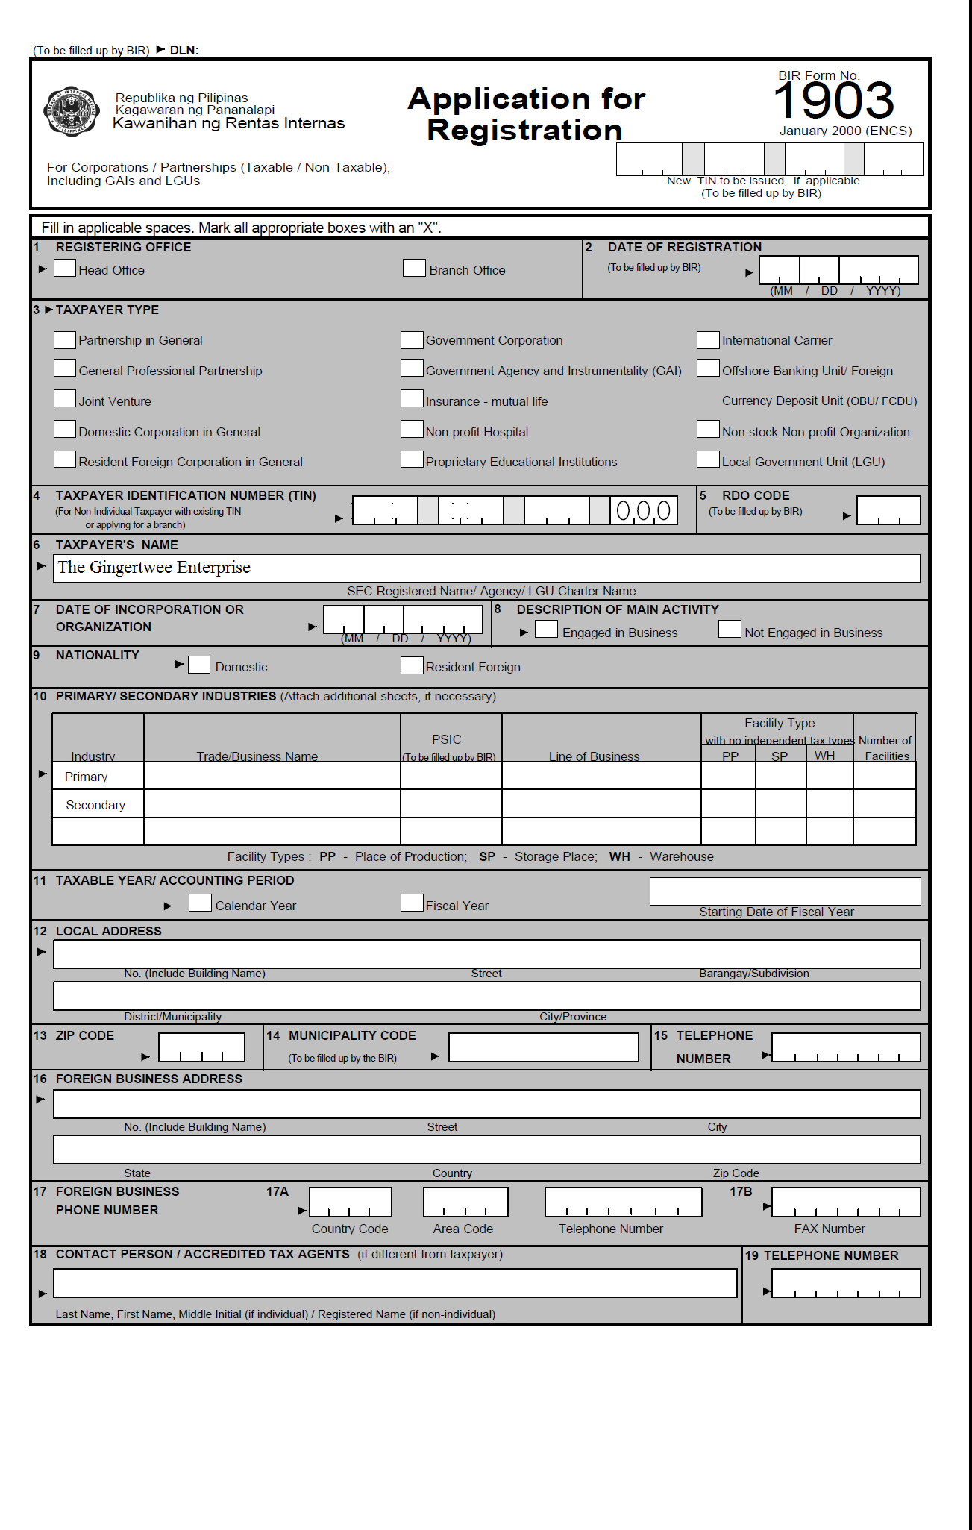
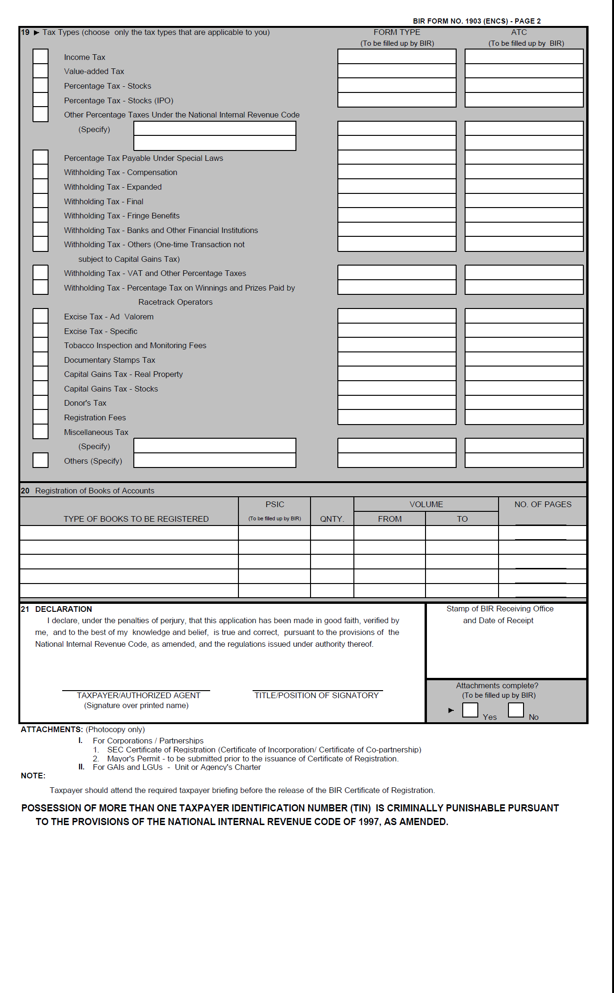
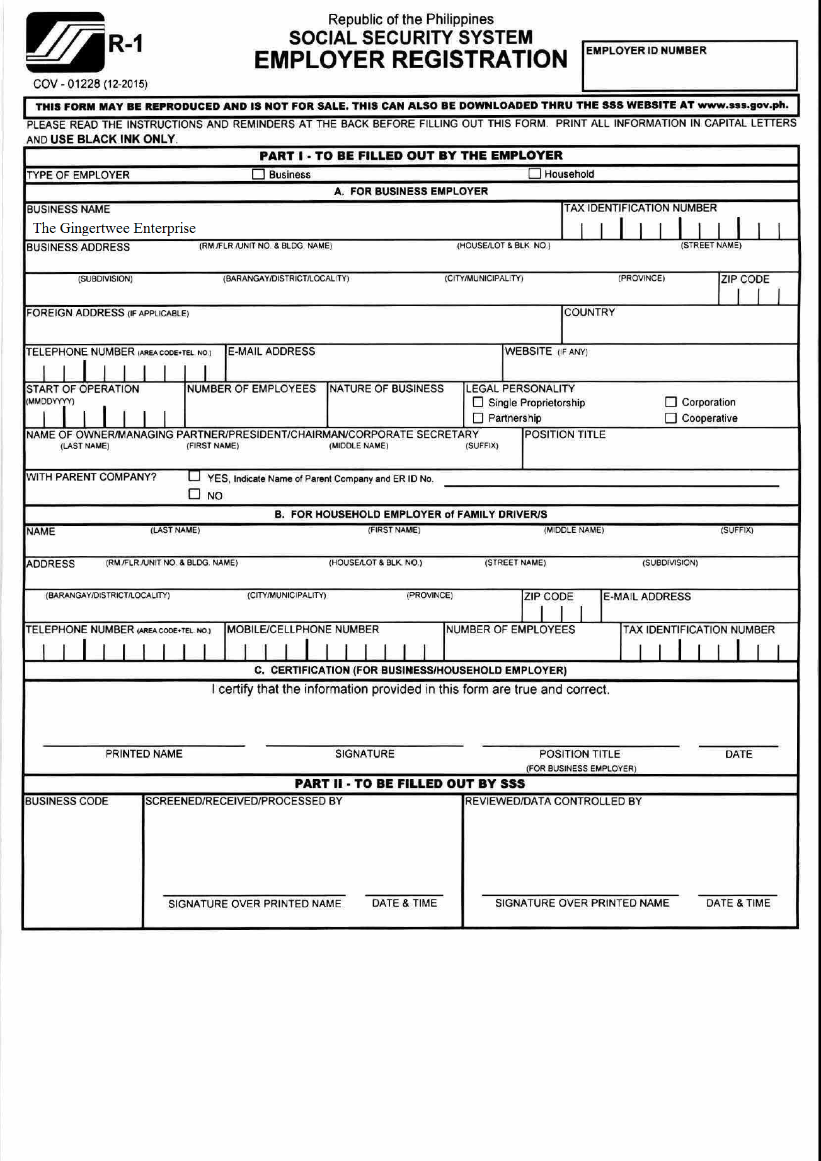

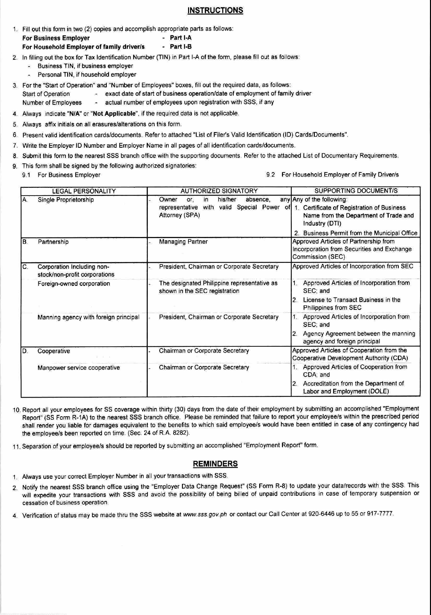

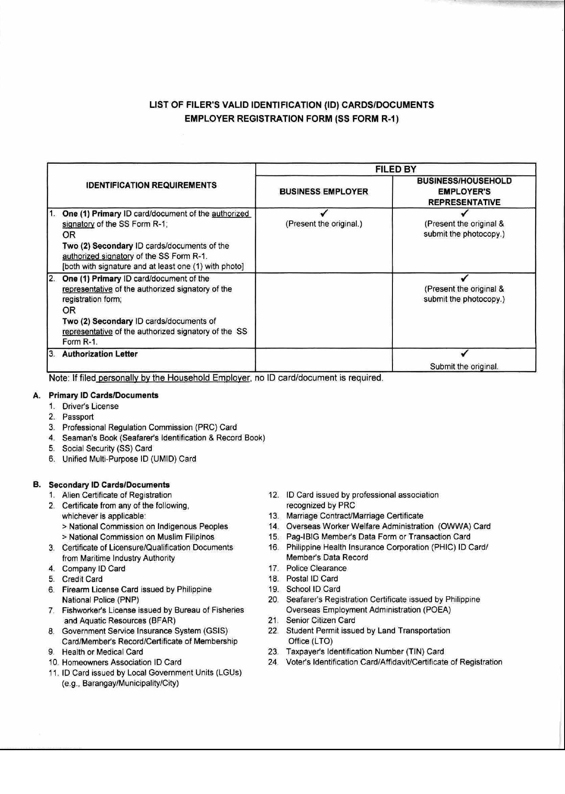

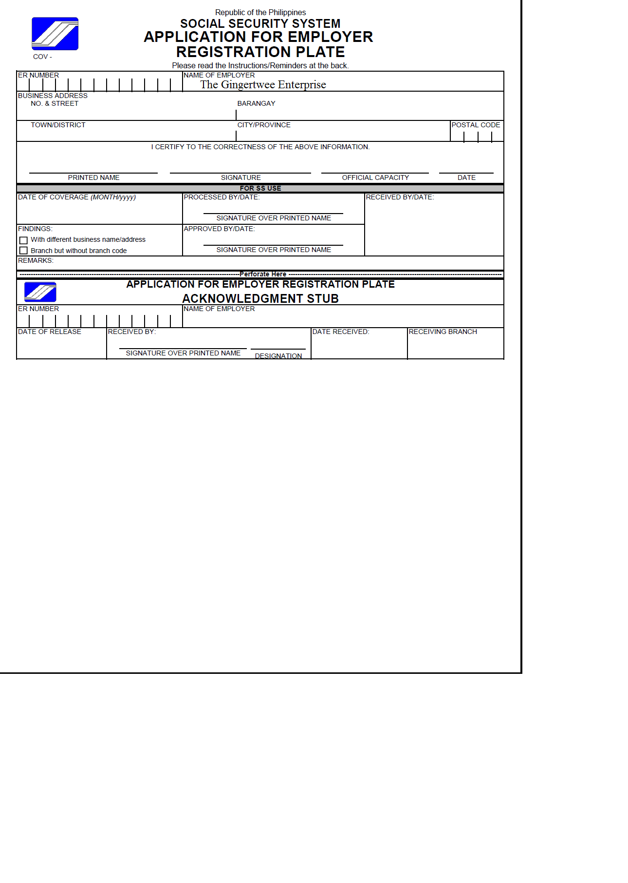


THE GINGERTWEE ENTERPRISE

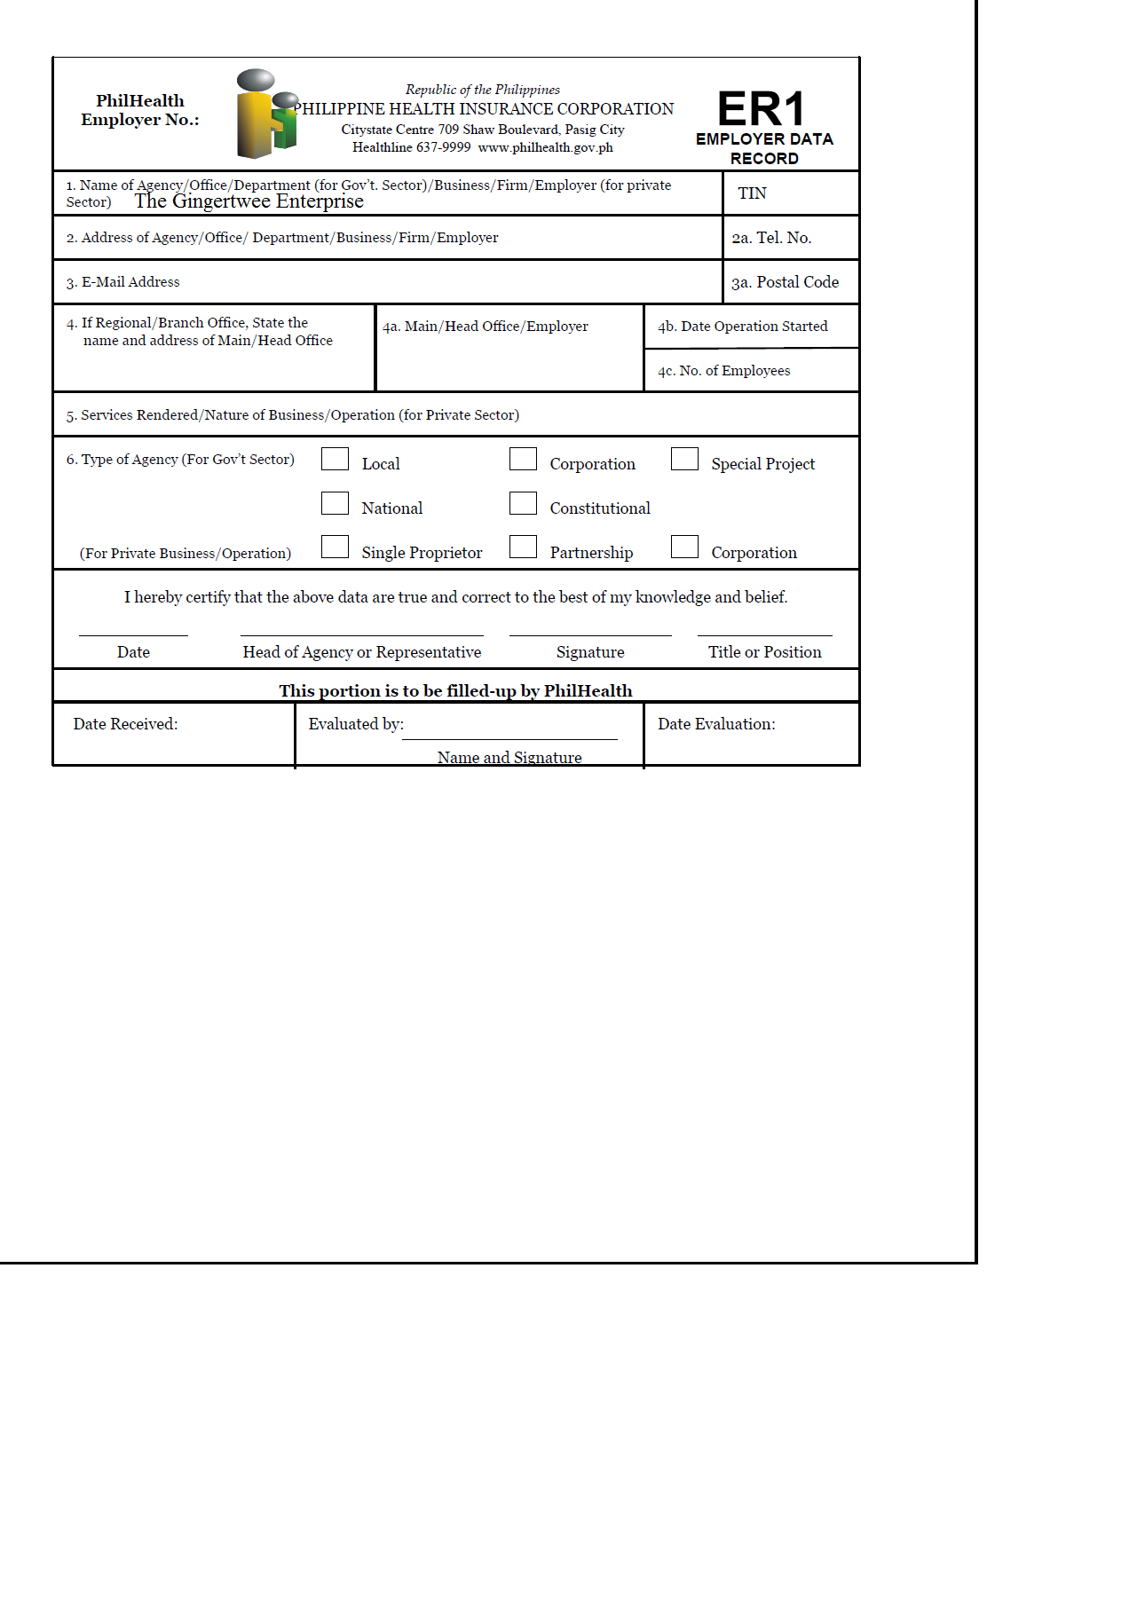
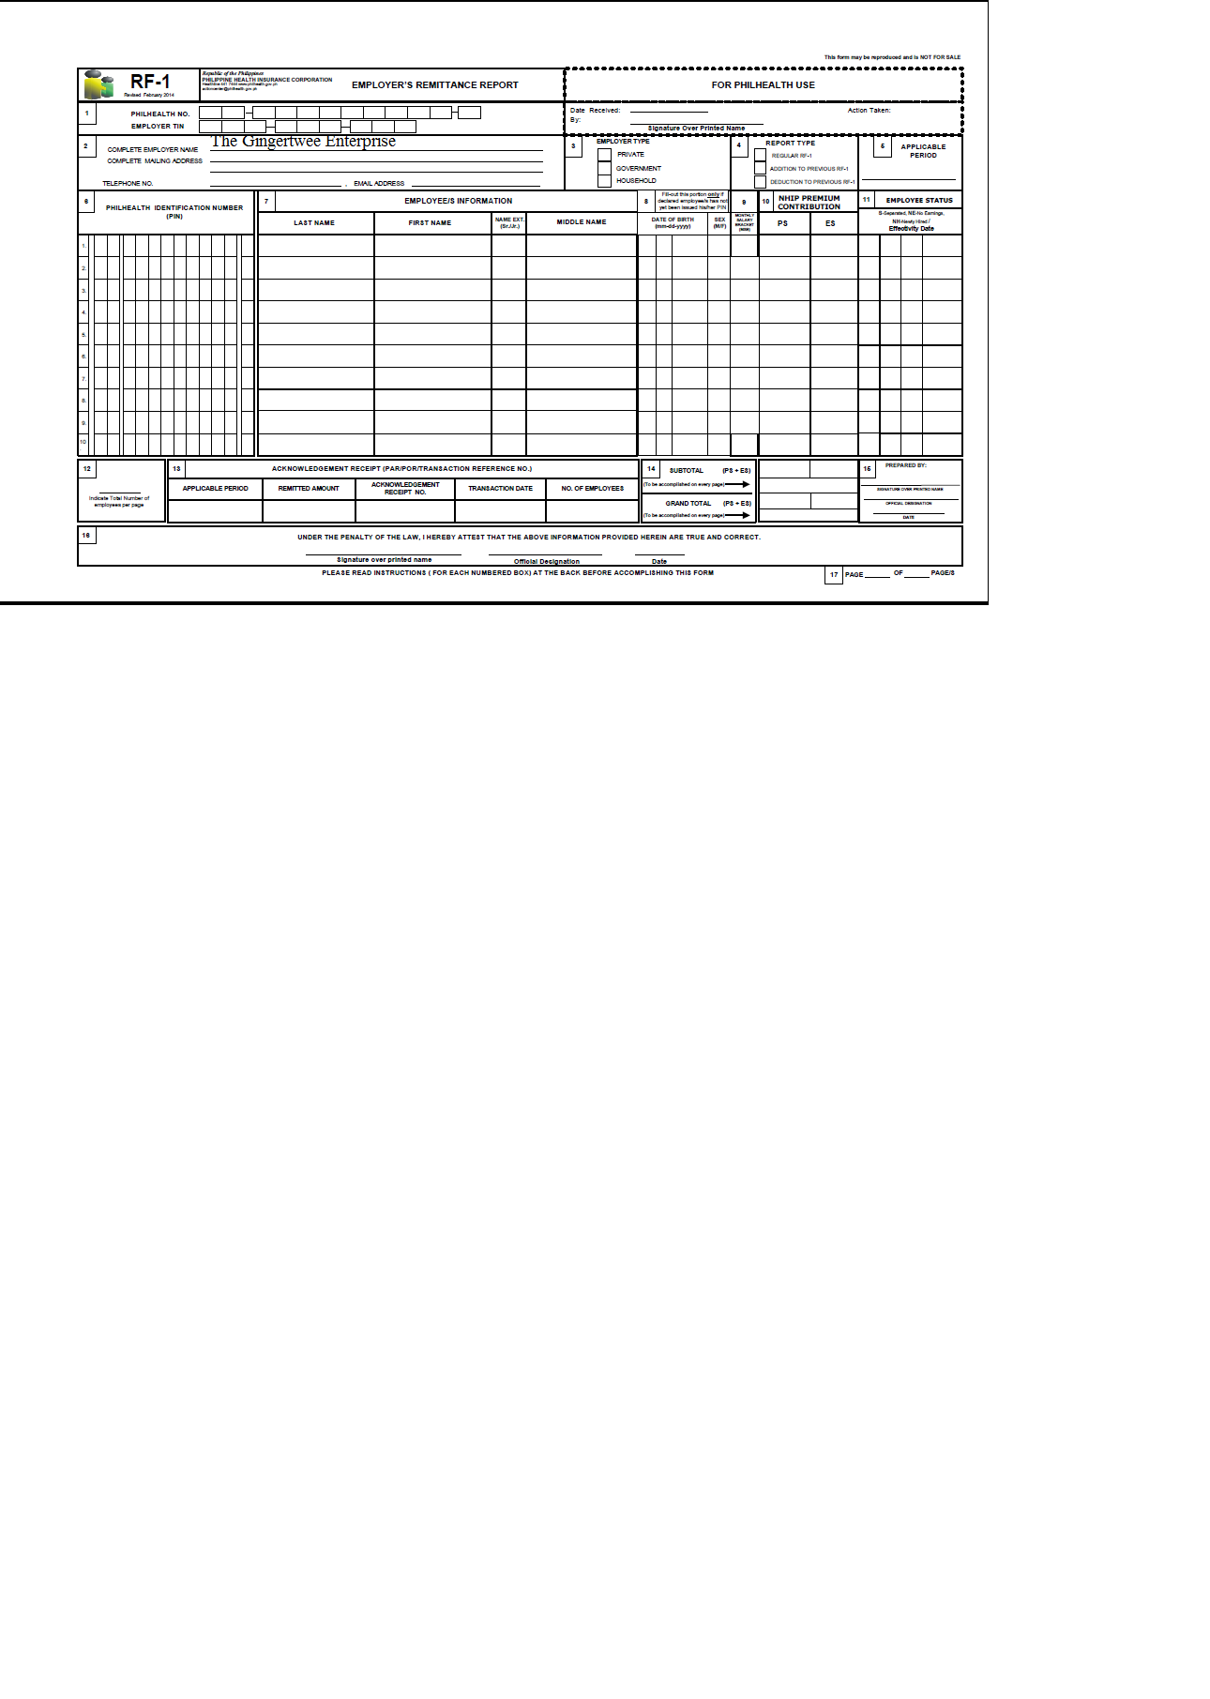
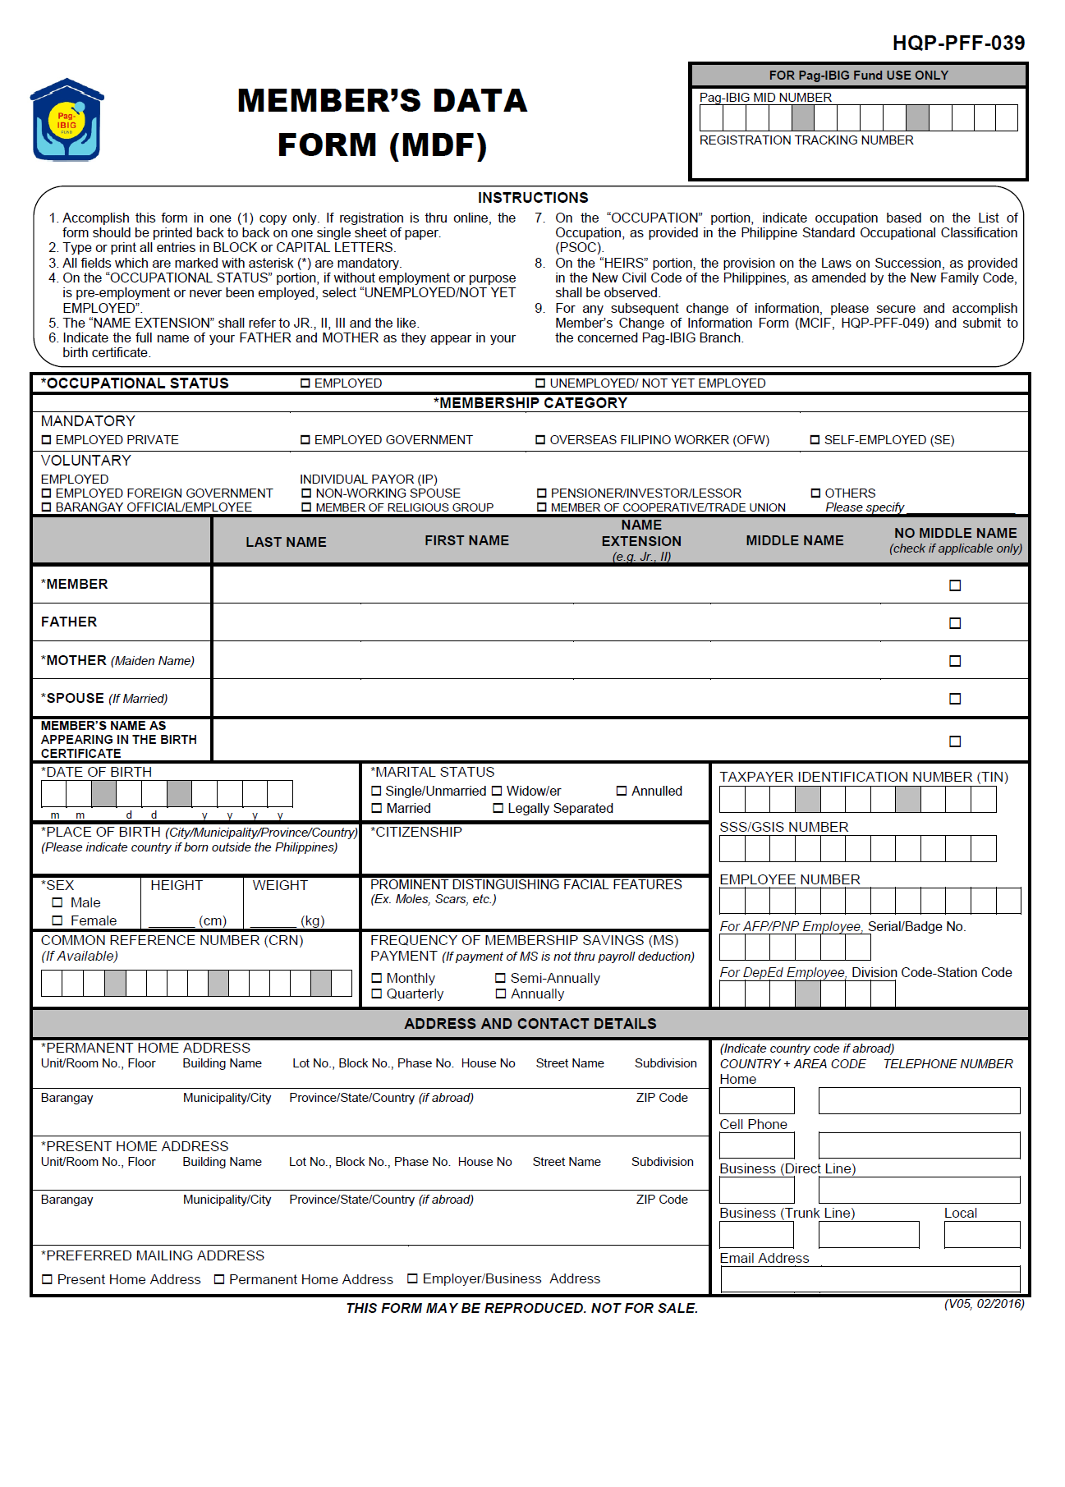

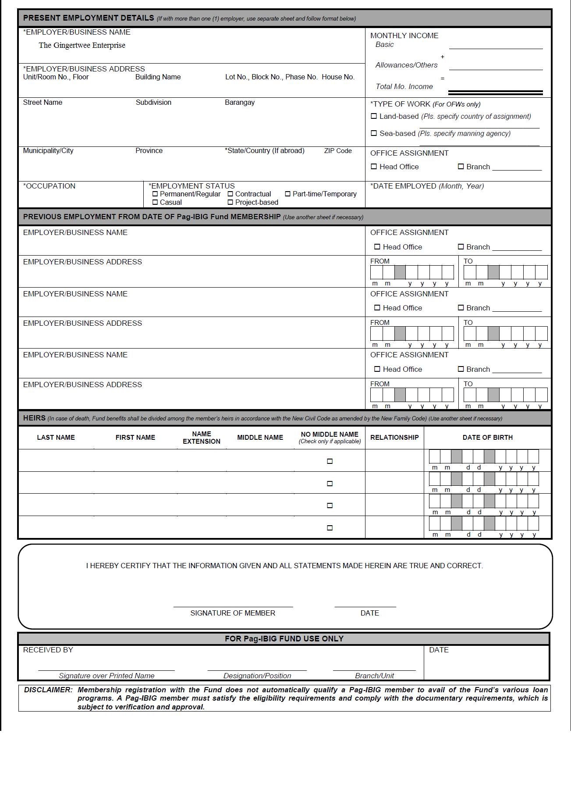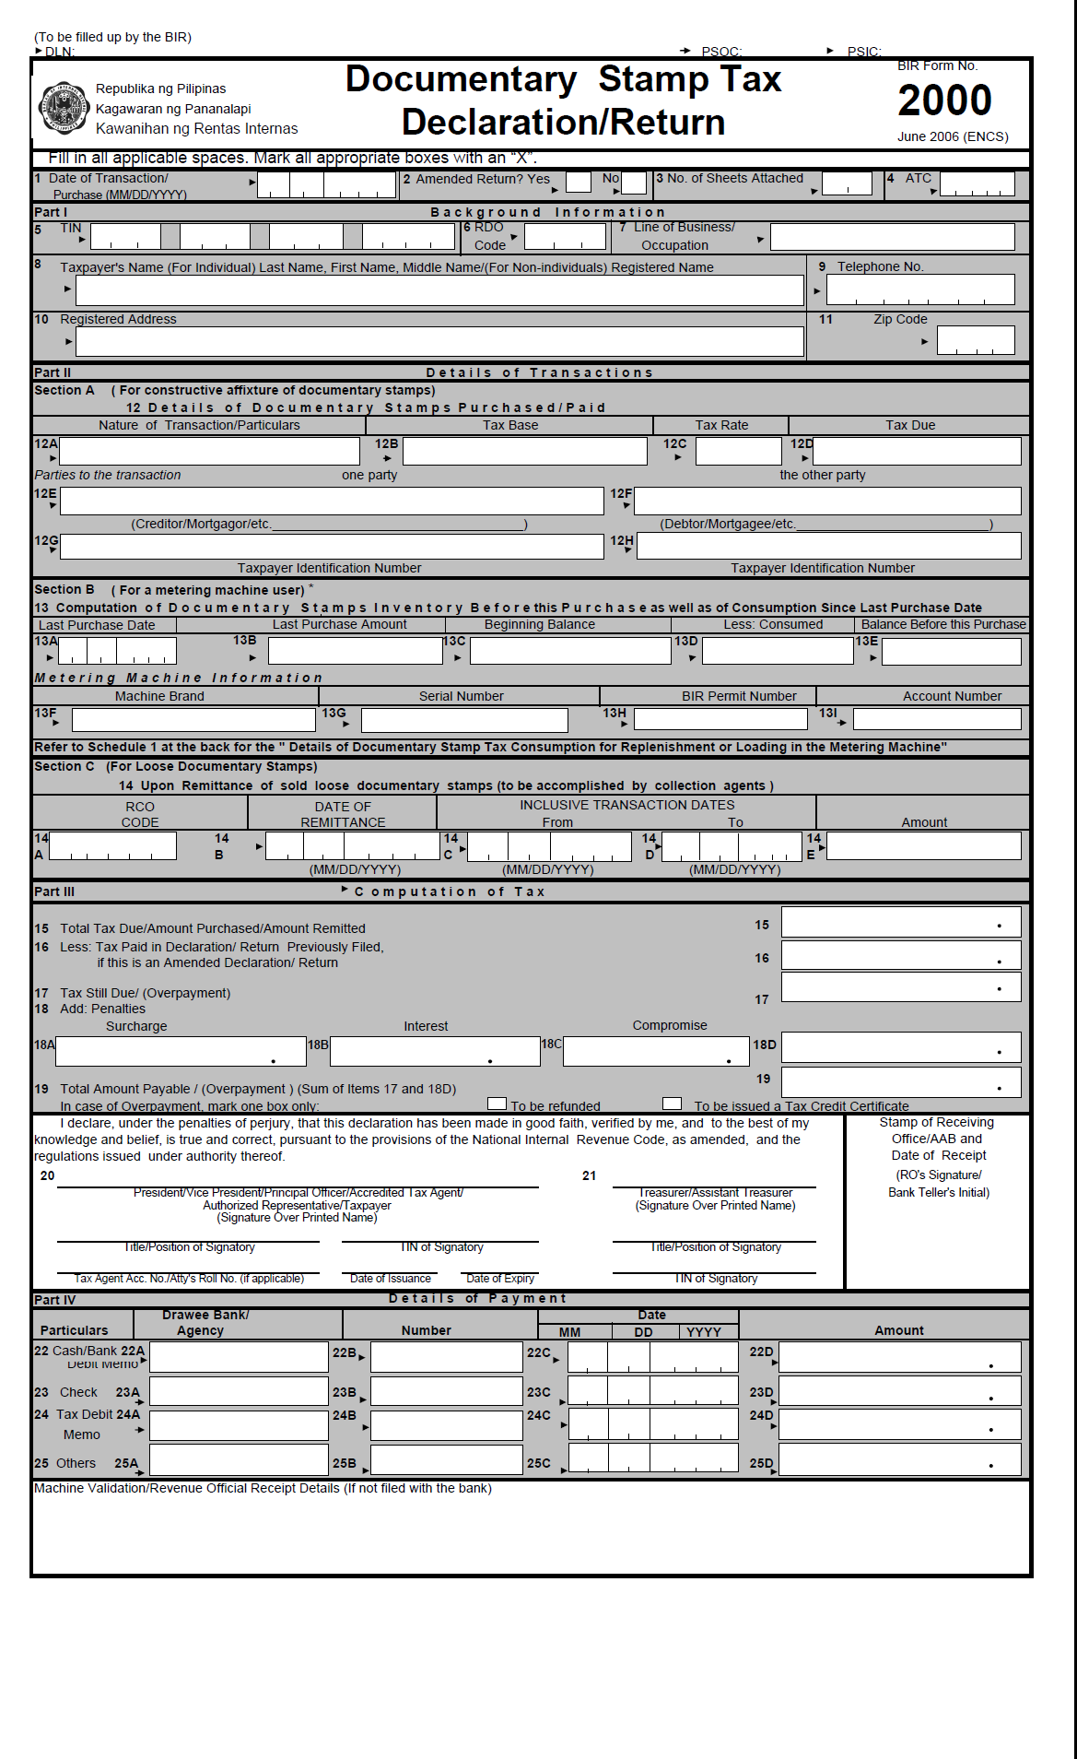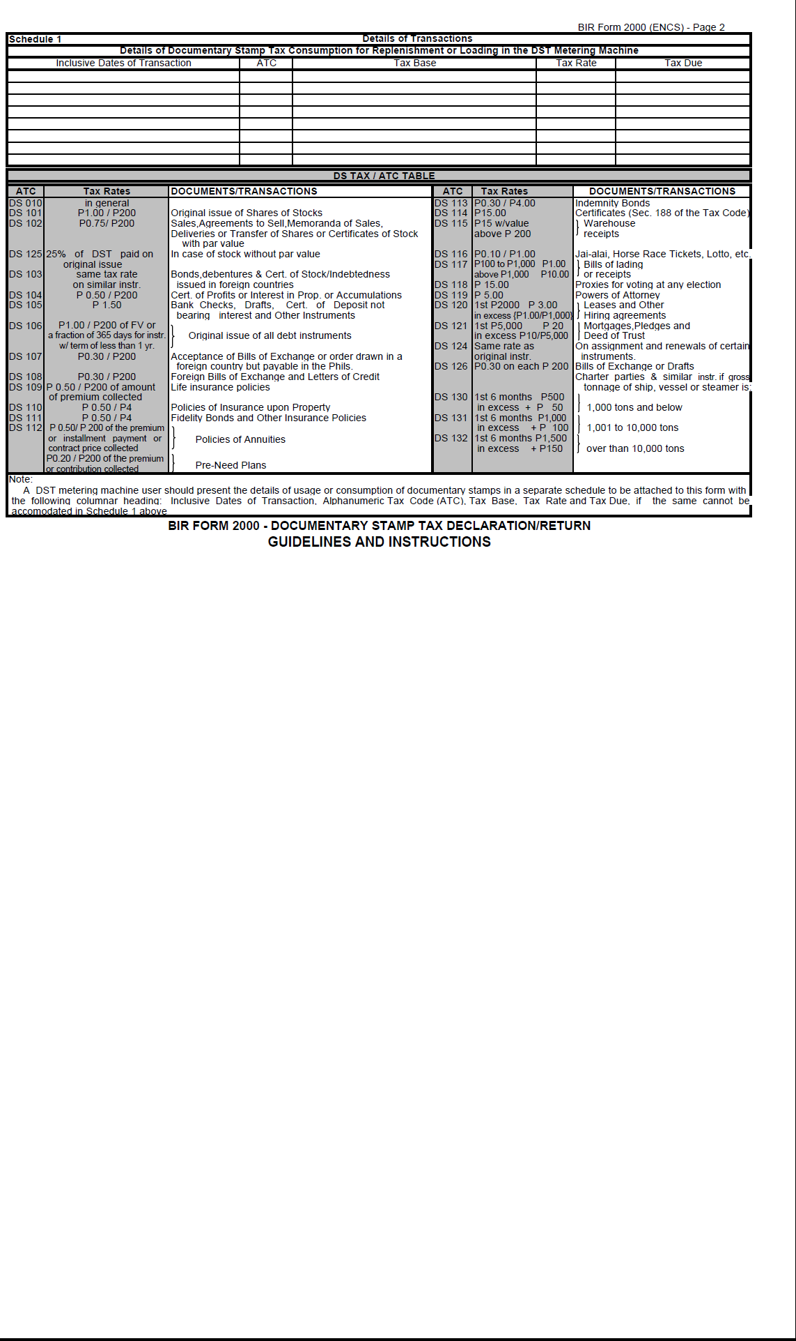

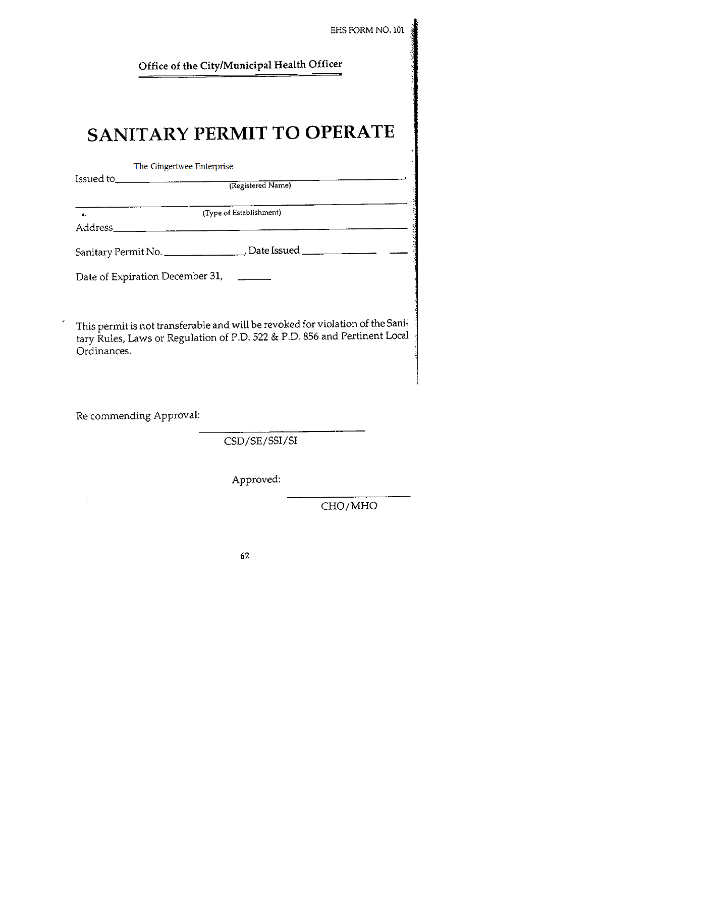

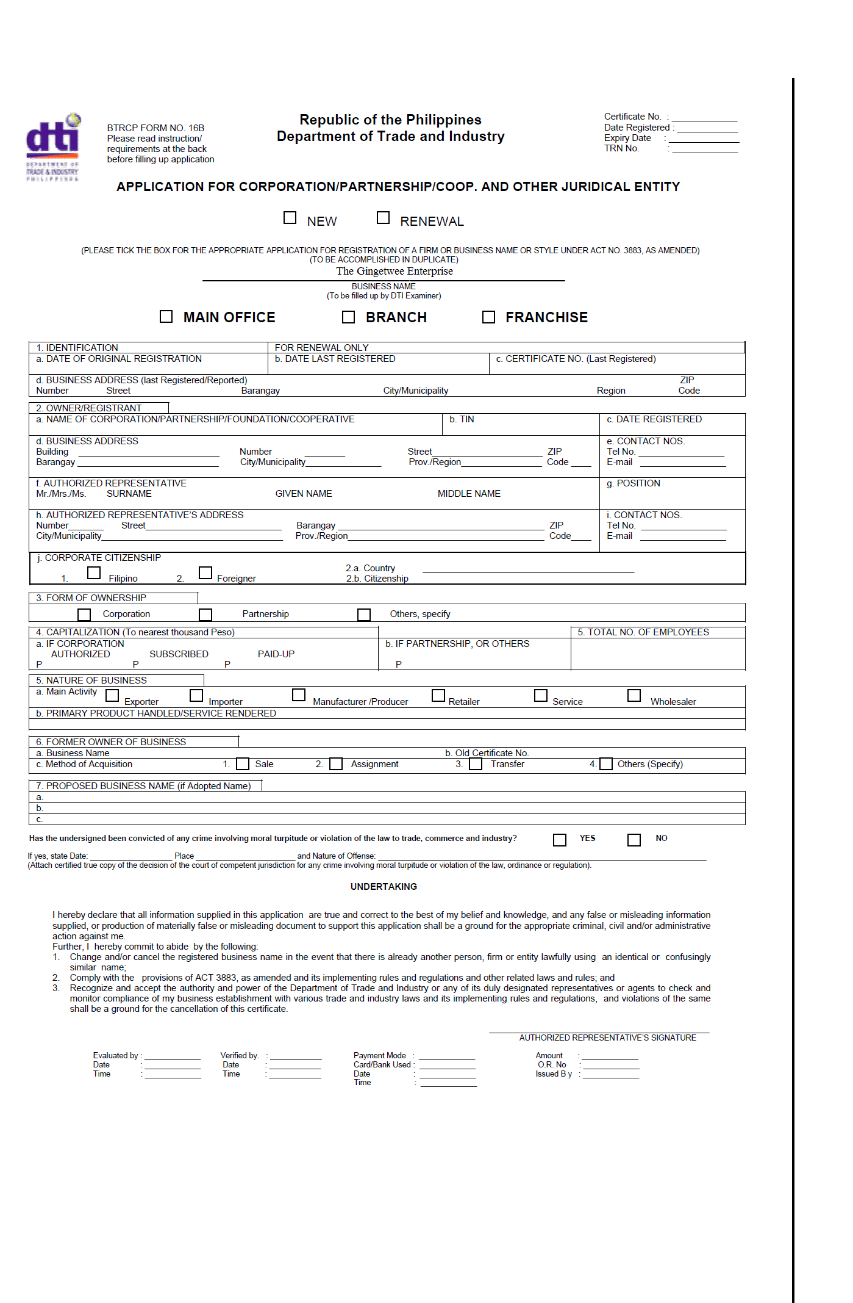
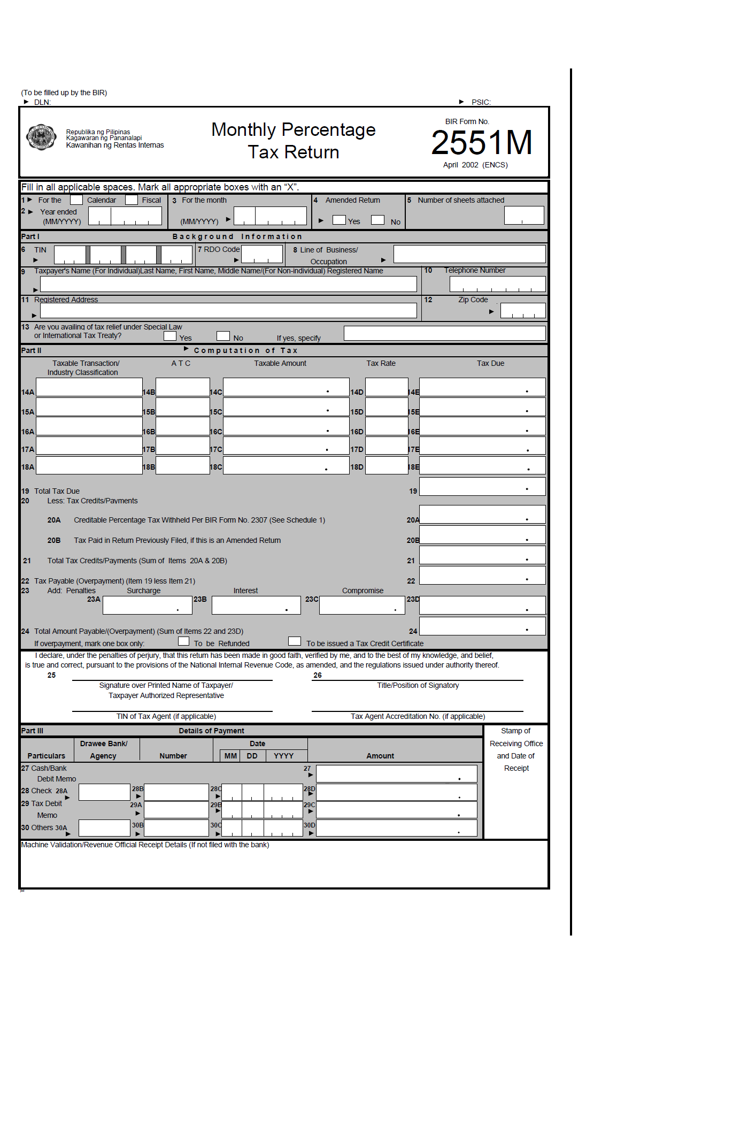

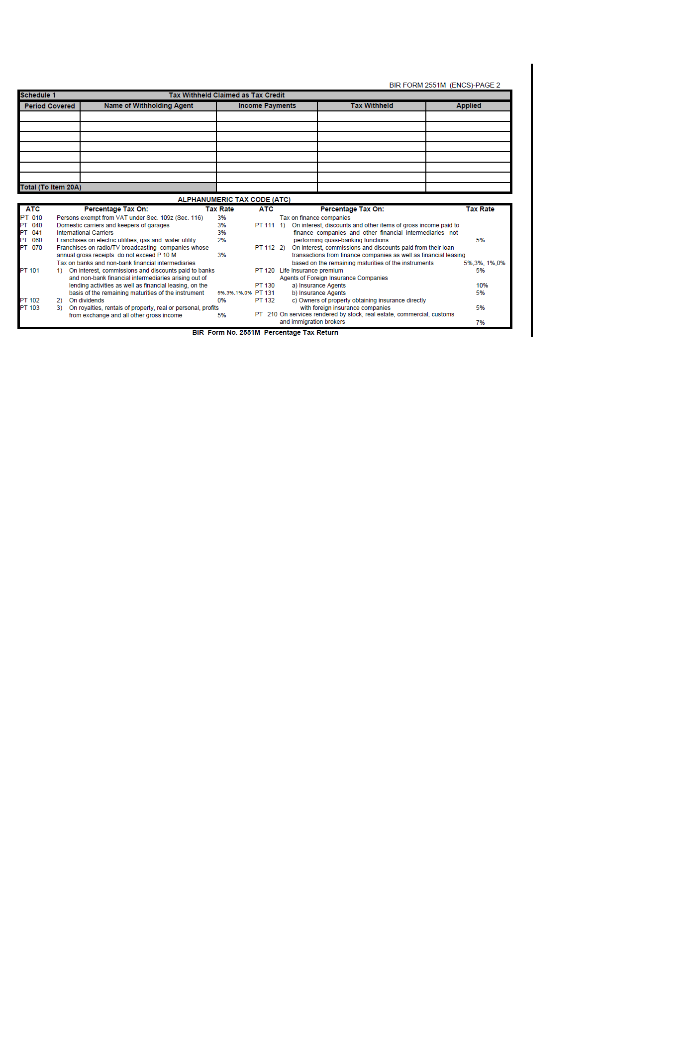

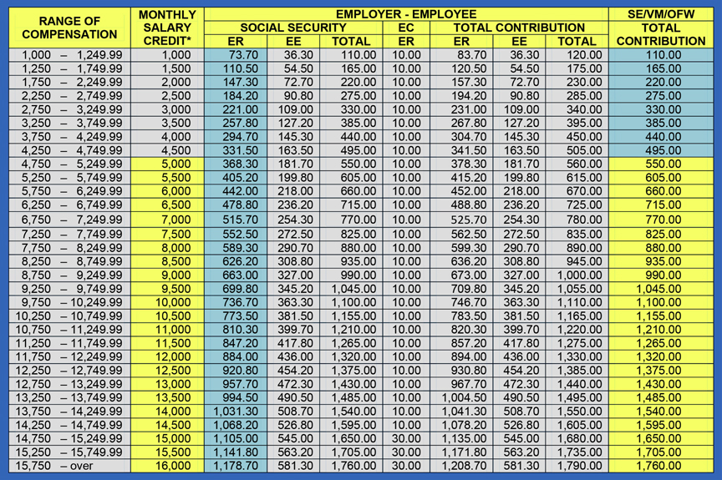
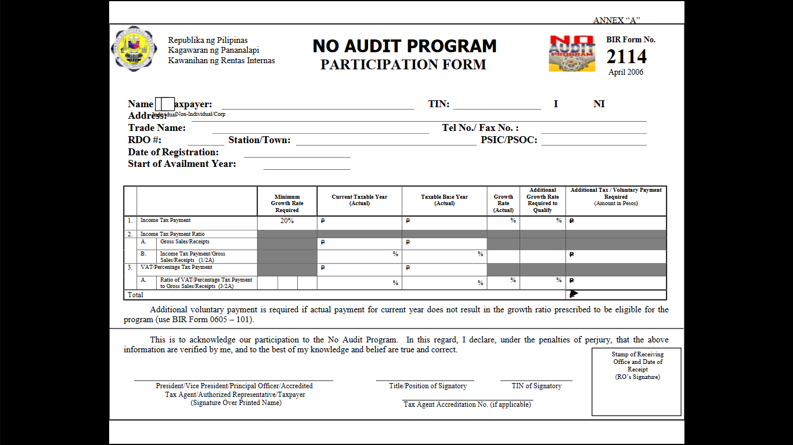

RODRIGO, MARLA GAIL A.
83 Kalinga Pelota Road, Camp 7, Kennon Road,
Baguio City, Philippines 2600
09757857641
myliie018@gmail.com
OBECTIVE: To use my acquired knowledge and skills in my chosen field and learn new knowledge and skills from the career in order to contribute to the community.
PERSONAL INFORMATION
Age: 20
Date of Birth: June 6, 1996
Place of Birth: Mandaluyong City
Civil Status: Single
Citizenship: Filipino
Language/Dialect: English, Filipino, Chinese Mandarin
Name of Mother: Minerva Rodrigo
Name of Father: Roberto Rodrigo
EDUCATIONAL BACKGROUND
COLLEGE SAINT LOUIS UNIVERSITY
School of Accountancy and Business Management, Baguio City
Bachelor of Science in Business Administration major in Financial Management
(June 2013 – Present)

SECONDARY BAGUIO PATRIOTIC HIGH SCHOOL
21 Harrison Road, Baguio City
(June 2009-March 2013)

ELEMENTARY BAGUIO PATRIOTIC HIGH SCHOOL
21 Harrison Road, Baguio City
(June 2005-March 2009)

SEMINARS ATTENDED
- “True Blue Louisian ka ba, sa isip at sa gawa? Discovering Roots, Directing Growth Year 3”
September 15, 2013
Devesse Plaza, Saint Louis University, Baguio City
- ”Comprehensive Agrarian Reform Program Extension with Reforms (CARPER) in Exit: Assessment of Stakeholders’ Convergence Initiatives”
November 23, 2014.
Prince Bernard Gym, Saint Louis University
- “Seminar on Financial Wellness”
January 19, 2014
Devess AVR, Saint Louis University Maryheights Campus
- “Agent Accountant 007: Decoding Crimes with Financial Analysis a Forensic Accounting Seminar”
February 25, 2014
AVR, Maryheights Campus, Bakakeng, Baguio City
- “EntrePinoy: Kapit-Bisig sa Pagbangon”
March 2, 2014
Maryheights Campus, Saint Louis University, Baguio City
- “Stock Investing 101: A Practical Guide to Investing in the Philippine Stock Market”
March 22, 2015
YMCA Functional Hall, Upper Session Road, Baguio City
- “Seminar on Financial Ethics”
October 24, 2016
Devesse Plaza, Saint Louis University, Baguio City
SKILLS/QUALIFICATIONS
- Hard Working and dedicated
- Computer literate
- Capable of working under pressure
- Good communication skills
- Flexible in working
ACHIEVEMENT
Feasibility Study: “Ginger-Lemongrass Syrup”
CHARACTER REFERENCE
Mr. Gerry O. Gatawa, MBA
Financial Management Instructor
Saint Louis University
(0928-386-6754)

I hereby certify that the above information is true and correct.

RODRIGO, MARLA GAIL A.


SIERRA, STEPHANIE D.
Ciudad Grande, Phase I, Bakakeng, Baguio City
Mobile: 0915-850-4819 E-mail: sd.sierra@yahoo.com

OBECTIVE: To apply actual learning from theories and acquire practical application, for personal growth and career opportunities
PERSONAL INFORMATION
Age 19 years old
Date of Birth February 16, 1997
Place f Birth Laoac, Pangasinan
Permanent Address San Vicente East, Urdaneta City, Pangasinan
Civil Status Single
Citizenship Filipino
Language/Dialect Filipino, Ilocano, English
Name of Mother Bhelle D. Sierra
Name of Father Robinson A. Sierra
EDUCATIONAL BACKGROUND
COLLEGE SAINT LOUIS UNIVERSITY
School of Accountancy and Business Management, Baguio City
Bachelor of Science in Business Administration major in Financial Management
(June 2013 – Present)
SECONDARY PANPACIFIC UNIVERSITY NORTH PHILIPPINES – Special Science High School
Urdaneta City, Pangasinan
(June 2009-March 2013)
ELEMENTARY PANPACIFIC UNIVERSITY NORTH PHILIPPINES – Montessori School
Urdaneta City, Pangasinan
(June 2005-March 2009)
HOLY CHILD ACADEMY
Binalonan, Pangasinan
(June 2003-March 2005)

SEMINARS ATTENDED
- Saint Louis University (SABM: Department of Financial Management) “Seminar on Financial Ethics” October 24, 2016
- Saint Louis University (SABM: Department of Financial Management) “Human Resources Seminar on Personal Branding and Surviving the Corporate World” October 24, 2016
- Saint Louis University (SABM: Department of Business Economics) ”Comprehensive Agrarian Reform Program Extension with Reforms (CARPER) in Exit: Assessment of Stakeholders’ Convergence Initiatives” November 23, 2014.
- Saint Louis University (SABM: Department of Entrepreneurship, Human resource Development Management, Marketing, and Young Entrepreneurship Society) “Entrep Fever EnterPinoy: Kapit-Bisig sa Pagbangon” March 2, 2014.
SKILLS/QUALIFICATIONS
- Committed to work
- Computer literate
- Capable of working under pressure
- Well-developed communication skills
- Unbiased towards working with people
ACHIEVEMENT
Champion (Group) – Entrep Fever 2014: Food Category
Editorial-Cartoonist – The Pinion: The Official Publication of SABM (2016)
Feasibility Study: “Ginger-Lemongrass Syrup”
CHARACTER REFERENCE
Mr. Gerry O. Gatawa, MBA
Financial Management Instructor
Saint Louis University
(0928-386-6754)

I hereby certify that the above information is true and correct.

SIERRA, STEPHANIE D.

